**Holmes Chapel Primary School My Behaviour Charter**

We want our school to be a calm, safe place for us to grow and to learn, and where we value and respect everyone.

To achieve this we will:

* Follow our school rules – Be kind, Be respectful, Be safe
* Listen and do what we are asked
* Show respect for other children and all adults, and for property

We are all responsible for our actions and understand that there are consequences for poor behaviour.

We understand that we will be spoken to and consequences explained privately and calmly, in the following ways:-

1. **Reminder** - A reminder of the school rules (Be kind, Be respectful, Be safe)
2. A clear **verbal caution** delivered privately wherever possible, making me aware of my behaviour and clearly outlining the consequences if I continue
3. **Time out** might be a short time out outside the room in the ‘safe place’, on the ‘thinking spot’ to calm down
4. **Repair** the situation by having a talk at break time. This is when we might miss part of a break time/playtime as a consequence for our actions
5. **Discussion with parents** and relevant staff - I may be included in this discussion
6. **Work with Mrs Lavin** to take part in a suitable behaviour support programme
7. I may have a behaviour **plan** to support me
8. If my behaviour is considered to be bullying behaviour (ie Several Times On Purpose, pre-meditated behaviour), the Anti-bullying policy will be followed
9. **Further consequences** are considered in discussion with parents/carers. This may be where I am not allowed to have contact with my own class or classmates and have to work somewhere else in school, or where I am not allowed to be in school and have to work at home

**I agree to abide by this charter – keep this at home to refer to**

|  |
| --- |
| My name: |
| My signature: |
| Date: |

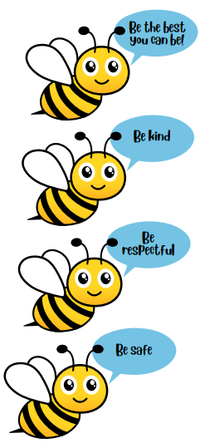

**Holmes Chapel Primary School**

**My Behaviour Charter**



