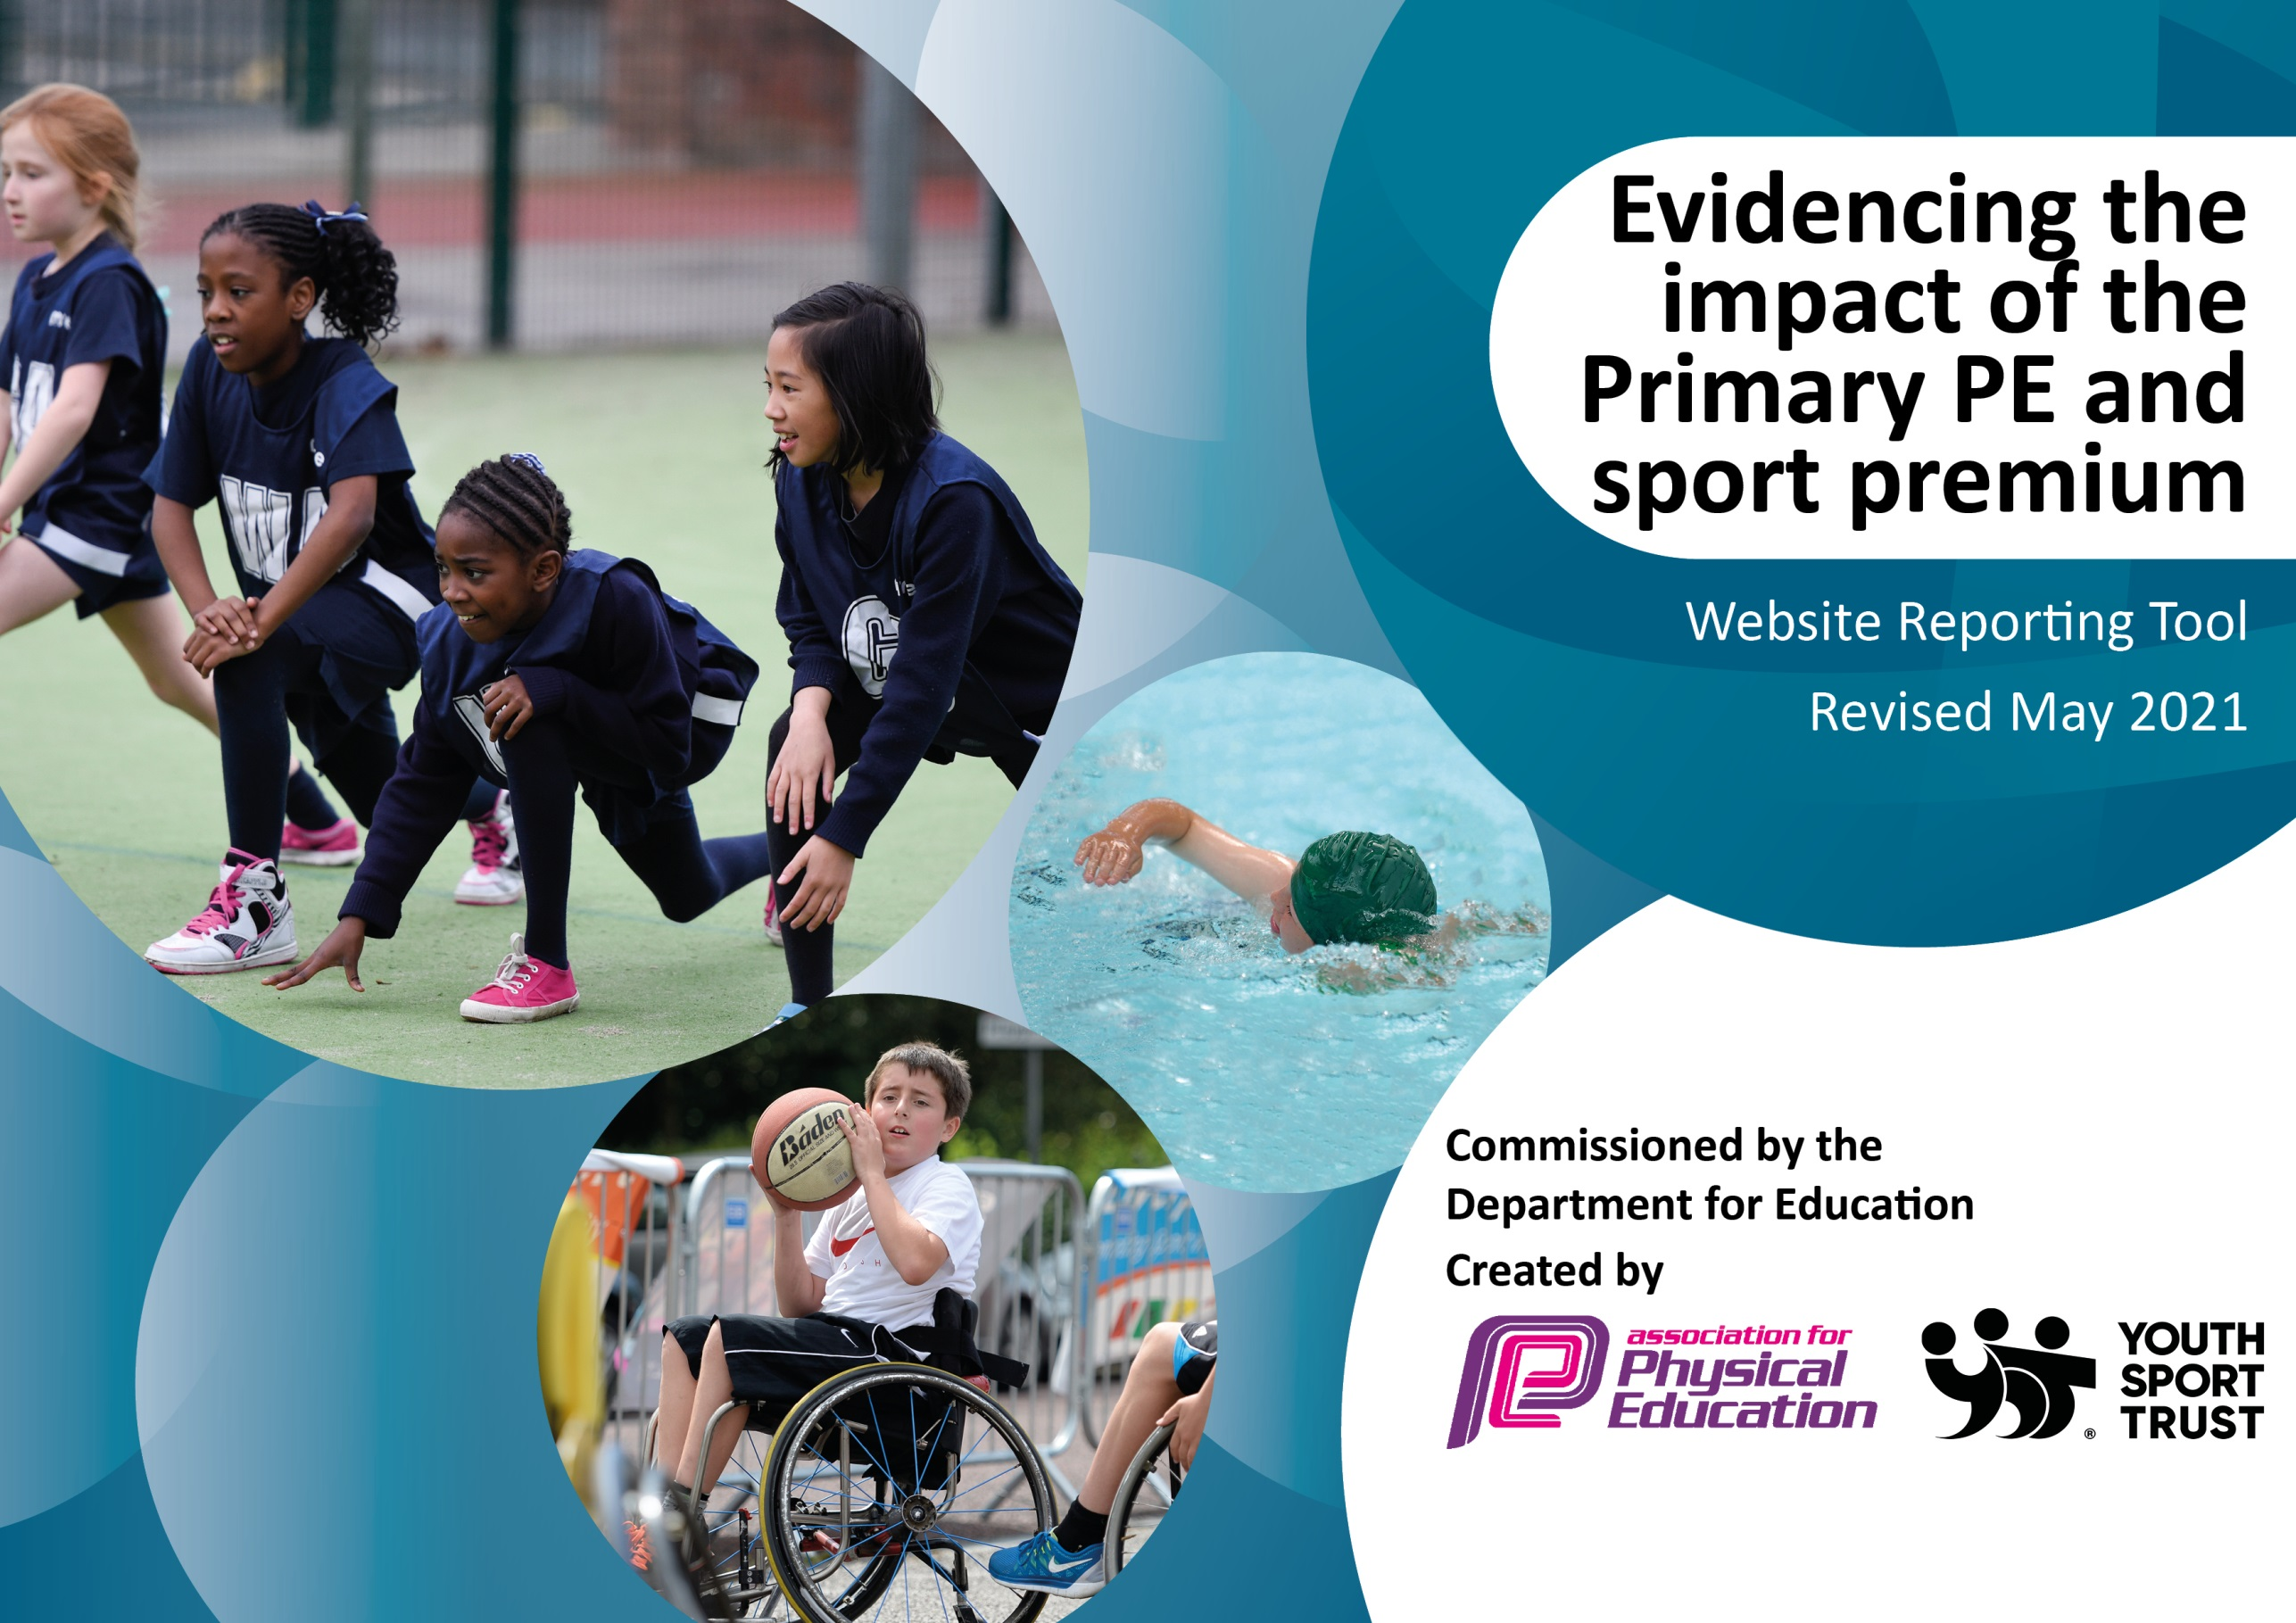

It is important that your grant is used effectively and based on school need. The Education Inspection Framework (Ofsted 2019 p64) makes clear there will be a focus on **‘whether leaders and those responsible for governors all understand their respective roles and perform these in a way that enhances the effectiveness of the school’**.

Under the Quality of Education criteria (p41) inspectors consider the extent to which schools can articulate their curriculum (INTENT), construct their curriculum (IMPLEMENTATION) and demonstrate the outcomes which result (IMPACT).

To assist schools with common transferable language this template has been developed to utilise the same three headings which should make your plans easily transferable between working documents.

Schools must use the funding to make **additional and sustainable** improvements to the quality of Physical Education, School Sport and Physical Activity (PESSPA) they offer. This means that you should use the Primary PE and sport premium to:

* Develop or add to the PESSPA activities that your school already offer
* Build capacity and capability within the school to ensure that improvements made now will benefit pupils joining the school in future years
* The Primary PE and sport premium should not be used to fund capital spend projects; the school’s budget should fund these.

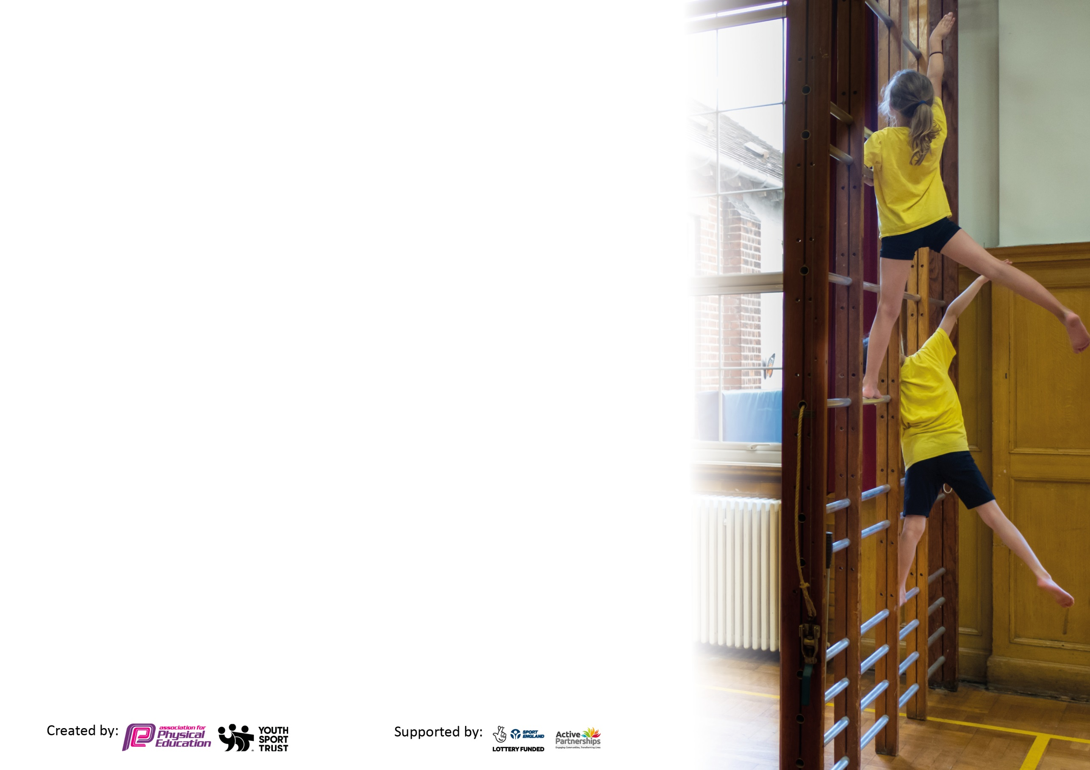

Please visit gov.uk for the revised DfE guidance including the 5 key indicators across which schools should demonstrate an improvement. This document will help you to review your provision and to report your spend. DfE encourages schools to use this template as an effective way of meeting the reporting requirements of the Primary PE and sport premium.

We recommend you start by reflecting on the impact of current provision and reviewing the previous spend.

Schools are required to publish details of how they spend this funding, including any under-spend from 2019/2020, as well as on the impact it has on pupils’ PE and sport participation and attainment by the end of the summer term or by **31st July 2024** at the latest.

We recommend regularly updating the table and publishing it on your website throughout the year. This evidences your ongoing self-evaluation of how you are using the funding to secure maximum, sustainable impact. Final copy must be posted on your website by the end of the academic year and no later than the 31st July 2021. To see an example of how to complete the table please click HERE.



|  |  |
| --- | --- |
| Key achievements to date until July 2024: | Areas for further improvement and baseline evidence of need: |
| * Range of activities available to children within school which promotes goal setting and growth mind-set. * We have continued to work with PE Passport, which has been very successful. It has been an effective planning scheme which has enhanced our PE curriculum. * Started evidencing PE iPads- saved photos/videos to the system. * We have bought iPads (one per year group) to help teachers with evidencing PE (moved from floor books due to cost of paper) and having the PE Passport accessible to all staff. * Sports Day has been very successful. Parents/carers have been able to attend which has been rewarding for them and children. * After school clubs have been successful this year. All sports clubs have been effective and engaging for children. We have introduced new sports. Pupil premium children are offered funded places. * We have continued with lunchtime sports activities with our Year 6 Play Leaders that has been positive and engaging across school. * Lunch time sports activities with sports coaches for all year groups have been effective in engaging children in active play. * Organised onsite swimming lessons for Year 4, 5 and 6 – this has had a positive impact on achievement towards national curriculum requirements for swimming. * Continued to raise the profile of Sports Ambassadors who are good role models and create legacy within HCPS. * Built links with local companies and sports clubs to provide more opportunities for pupils. * Clare end points for PE – staff use end points as goals for teaching and for assessment. * Amaven testing- staff to use reports for assessment and intervention. * Golden Mile has been used as a school competition instead of using an outside agency – display in school to raise the profile and promote encouragement. Trophy has awarded each half term. Display has shown progress across all year groups. KS1/KS2 winner.   Competitions:   * Continued to raise the profile of intra school competitions to provide a level of competition for all children across the entire school. * Trust football event. This was very successful and the children thoroughly enjoyed it. * Intra school competitions at the end of each unit within year groups or classes/houses. * Given every child within HCPS the opportunity to compete during PE sessions each term. * Allow opportunities for children to participate in competitive sports against other schools with the MAT. * Celebrate achievements of children participating in competitions to the whole school (eg. Facebook, website, assemblies, display) * 22 different events within the Sandbach cluster, which have involved 11 different sports. We have enjoyed many successes, especially in 5/6 netball, tag rugby, cricket and girls' football and 3/4 football, rounders and athletics, and all competitors have been celebrated in praise assemblies. * Holiday clubs run onsite – pupil premium children offered funded places. | * Set up and run a Sports blog/ website page for match reports and updates. * Research training opportunities for staff- swimming training/qualifications * Staff meeting- staff have been shown where to access Amaven results for each assessment. Assessment –Monitor to ensure that Amaven assessment is being used effectively. * Develop links with local newspaper * Work towards achieving Bronze or Silver School Games Mark Award * Provide midday assistants with CPD to promote activity at lunchtimes. * Look at starting a staff running club or sports wellbeing club. * After school clubs run by staff – free spaces for pupil premium children and other children. * Promote after school clubs for PP, SEN, Disadvantaged pupils – actively encourage participation * At the end of a unit, children to share a performance i.e dance to key stages or whole school. * Clearly define the role of play leaders and how they can support sports coaches at lunchtimes. Provide play leaders a bib/cap so younger children are aware of who they are at playtimes. * Children have enjoyed the golden mile competition across key stages and have been motivated to win the trophy for their class- continue to promote golden mile across the school.   Competitions:   * Celebrate sports more in assemblies to raise the raise of PE. * Increase the intra-school house competitions to celebrate 3 different sports. * Reinforce the message of competing within classes or year groups, e.g. at the end of a unit of work. |

|  |  |
| --- | --- |
| Meeting national curriculum requirements for swimming and water safety.  N.B Complete this section to your best ability. For example you might have practised safe self-rescue techniques on dry land which you can transfer to the pool when school swimming restarts.  **Due to exceptional circumstances priority should be given to ensuring that pupils can perform safe self-rescue even**  **if they do not fully meet the first two requirements of the NC programme of study.** | |
| What percentage of your current Year 6 cohort swim competently, confidently and proficiently over a distance of at least 25 metres?  **N.B.** Even though your pupils may swim in another year please report on their attainment on leaving primary school at the end of the summer term 2023.  Please see note above. | 78% |
| What percentage of your current Year 6 cohort use a range of strokes effectively [for example, front crawl, backstroke and breaststroke]?  Please see note above. | 96% |
| **What percentage of your current Year 6 cohort perform safe self-rescue in different water-based situations?** | 96% |
| Schools can choose to use the Primary PE and sport premium to provide additional provision for swimming but this must be for activity **over and above** the national curriculum requirements. Have you used it in this way? | No, however a significant proportion of time this year has been spent teaching the current Year 4/5 cohort. |

**Action Plan and Budget Tracking**

Capture your intended annual spend against the 5 key indicators. Clarify the success criteria and evidence of impact that you intend to measure to evaluate for pupils today and for the future.

|  |  |  |  |  |
| --- | --- | --- | --- | --- |
| **Academic Year:** 2023/24 | **Total fund allocated: £24,176** | **Date Updated: 16/07/2024** | |  |
| **Key indicator 1:** The engagement of all pupils in regular physical activity – Chief Medical Officers guidelines recommend that primary school pupils undertake at least 30 minutes of physical activity a day in school | | | | Percentage of total allocation: |
|  |
| **Intent** | **Implementation** | | **Impact** | 44% |
| Your school focus should be clear what you want the pupils to know and be able to do and about  what they need to learn and to  consolidate through practice:  Increase physical activity within lessons and during playtime.  Increase physical activity at lunchtimes.  Increase physical activity within lessons to make it more enjoyable and active for children that need it. | Make sure your actions to achieve are linked to your intentions: | Funding allocated: | Evidence of impact: what do pupils now know and what can they now do? What has changed?: | Sustainability and suggested next steps: |
| Golden mile - in house scheme which involves children running around the track (trim trail) and laps counted and converted into miles.  Trophy engraving | £0  £8 | Improvements in fitness and gross motor skills. These will also bring an expected improvement in concentration levels and fine motor skills in the classroom.  Children given the opportunity to develop their cardiovascular fitness and growth mind-set. Higher level children are recognised immediately from the amount of laps they can run without stopping. This has also helped promote emotional well-being within school. | Next steps - to continue to promote the scheme next year and celebrate those who achieve mile stones.  Evaluate appropriateness for SEND children. Find ways to adapt data collection for those children with special needs.  Continue with the golden mile competition and display. |
| Lunchtime and afternoon sessions with an outside agency  Additional coach for lunch club | £770  £1,680  £1,760  £1,595  £1,760  £2,340  £250 | Improved engagement in lunchtime activities. It helped children socialise and learn new skills. Children were encouraged to become active and competitive. | Monitor lunchtime activities. We are now using our Year 6 Play Leaders to encourage physical activities.  Training for new play leaders by the P.E lead. Ensure play leaders encourage younger children to participate in lunchtime activities.  Provide bibs/caps for play leaders so younger children are aware of who they are on the playground. |

|  |  |  |  |  |
| --- | --- | --- | --- | --- |
| **Key indicator 2:** The profile of PESSPA being raised across the school as a tool for whole school improvement | | | | Percentage of total allocation: |
|  |
| **Intent** | **Implementation** | | **Impact** | 1% |
| Your school focus should be clear what you want the pupils to know and be able to do and about  what they need to learn and to  consolidate through practice: | Make sure your actions to achieve are linked to your intentions: | Funding allocated: | Evidence of impact: what do pupils now know and what can they now do? What has changed?: | Sustainability and suggested next steps: |
| Increase engagement and enjoyment of participating in Physical Activity.  Use PE as a vehicle to support the whole school ethos.  Promote healthy living and fitness. | Head Teacher kept fully aware of progress in PE and school sport and close monitoring of the impact of the PE and school sports Premium (business manager). | £0 |  | Communication to continue next year. |
| New and replacement equipment,  Tennis Balls | £75 | Equipment have been replaced to ensure children are safe.  Play Leader equipment helps them deliver high quality activities. It encourages children to play with the play leaders learning new physical activities. | Continue to monitor equipment and effectiveness of play leaders. Play leaders to be support by subject lead. |

|  |  |  |  |  |
| --- | --- | --- | --- | --- |
| **Key indicator 3:** Increased confidence, knowledge and skills of all staff in teaching PE and sport | | | | Percentage of total allocation: |
|  |
| **Intent** | **Implementation** | | **Impact** | 1% |
| Your school focus should be clear | Make sure your actions to | Funding | Evidence of impact: what do | Sustainability and suggested |
| what you want the pupils to know | achieve are linked to your | allocated: | pupils now know and what | next steps: |
| and be able to do and about | intentions: |  | can they now do? What has |  |
| what they need to learn and to |  |  | changed?: |  |
| consolidate through practice: |  |  |  |  |
| Continue to support staff confidence, competence and subject knowledge through CPD and improved access to resources.  Continue to work with PE Passport as a scheme of work across entire school. | Continue to audit and replenish PE equipment, using the play leaders, sports coaches (Sports Coaching Group) and staff to identify need for new equipment. | £0  (Equipment costs already mentioned above). |  | Extend knowledge and understanding by continuing to train staff in areas of PE. Staff to be asked.  Subject leader to team teach and observe lessons. |
| PE Passport – annual subscription to guide staff and excel their confidence in planning and teaching PE. | £300 | Staff have started to excel in planning and teaching PE. Staff have enjoyed using PE Passport to help teach high quality lessons. | Continue to monitor the effectiveness of PE and support staff where needed. |
| Staff meeting for P.E  Training | £0 |  | Continue to monitor staff confidence in sports and other areas. |

|  |  |  |  |  |
| --- | --- | --- | --- | --- |
| **Key indicator 4:** Broader experience of a range of sports and activities offered to all pupils | | | | Percentage of total allocation: |
| 45% |
| **Intent** | **Implementation** | | **Impact** | Next steps |
| Your school focus should be clear | Make sure your actions to | Funding | Evidence of impact: what do | Sustainability and suggested |
| what you want the pupils to know | achieve are linked to your | allocated: | pupils now know and what | next steps: |
| and be able to do and about | intentions: |  | can they now do? What has |  |
| what they need to learn and to |  |  | changed?: |  |
| consolidate through practice: |  |  |  |  |
| To provide opportunities for children to experience a wide range of sports and activities.  Widen the experiences offered to children within school  To provide children with swimming lessons as part of the national curriculum. | After school clubs – Holmes Chapel Primary School have paid for PP families to participate in clubs. | £240  £115  £227  £215  £165  £250 | Children have really enjoyed the variety of after school clubs this year. We have offered PP families a place for free. Clubs have raised the profile of PE and allowed children to be competitive. The children have loved learning new sports. | Continue with after school clubs with Sports Coaching Group, Shooting Stars and members of staff. |
| Swimming lessons  Onsite swimming pool  Year 4, 5 and 6 – children have been able to learn a range of strokes, perform self-rescue and learn to swim 25m.  Water and electrics  Gazebos for swimming lessons | £3,400  £1,798  £777 | As part of the national curriculum children have been taught 3 areas they should achieve by the end of year 6. Children have enjoyed going swimming plus staff have been able to have some CPD attending with children.  Provide a place for the children to get changed and then enter the pool. | Continue with swimming and onsite swimming lessons next year. |
| Amaven Days  Amaven License | £500  £500  £2,000 | The children have been assessed across different areas for P.E. These assessments are then used by class teachers to determine any child who need additional support in P.E. | Continue with Amaven testing next year. |

|  |  |  |  |  |
| --- | --- | --- | --- | --- |
| **Key indicator 5:** Increased participation in competitive sport | | | | Percentage of total allocation: |
|  |
| **Intent** | **Implementation** | | **Impact** | 9% |
| Your school focus should be clear | Make sure your actions to | Funding | Evidence of impact: what do | Sustainability and suggested |
| what you want the pupils to know | achieve are linked to your | allocated: | pupils now know and what | next steps: |
| and be able to do and about | intentions: |  | can they now do? What has |  |
| what they need to learn and to |  |  | changed?: |  |
| consolidate through practice: |  |  |  |  |
| Give every child within HCPS the opportunity to compete during PE sessions each term. | Sports Day | £0 | Children thoroughly enjoyed Sports Day. | Continue next year to promote participation in competitive sports across the entire school through competitions in year groups (Golden Mile, Amaven and competitions). |
| Give children the chance to compete against other schools. | Sports partnership contribution | £2,047 | The children that have attended the competitions have been really pleased with the progress they have made. They have learnt many skills. | Continue to take children to competitions. Look at giving all children the opportunity to participate in outside competitions. |

**Money left after spending to carry forward: -£36**

|  |  |
| --- | --- |
| Signed off by | |
| Head Teacher: | Fiona Gresty |
| Date: | 19/07/24 |
| Subject Leader: | Miss M MacWilliam |
| Date: | 16/07/24 |
| Governor: | Roger Dixon |
| Date: | 23/07/24 |