Holmes Chapel Primary School - Reading Rationale

The National Curriculum
The national curriculum for English aims to ensure that all pupils:
- read easily, fluently and with good understanding
- develop the habit of reading widely and often, for both pleasure and information
- acquire a wide vocabulary, an understanding of grammar and knowledge of linguistic conventions for reading, writing and spoken language
- appreciate our rich and varied literary heritage
- use discussion in order to learn; they should be able to elaborate and explain clearly their understanding and ideas

Reading Intent
At Holmes Chapel Primary School, we recognise the value of English as a means of communicating through the elements of spoken language, reading and writing. We aim to promote high standards of language and literacy in our children by equipping them with a strong command of the spoken and written word, and develop their love of literature through widespread reading for pleasure and enjoyment.
At Holmes Chapel Primary School, we believe that the ability to read is fundamental to pupils’ development as independent learners, during their time at school and beyond. Reading is central to our ability to understand, interpret and communicate with each other and the world around us. Success in reading has a direct effect on progress in all areas of the curriculum; therefore reading is given a high priority at Holmes Chapel Primary School, enabling the children to become enthusiastic, independent and reflective readers across a wide range and types of literature, including different text types and genres, book, posters, magazines, signs and newspapers. Reading is a complex skill with many components. Successful approaches to the teaching of reading should encourage children to use a variety of strategies in their pursuit of meaning. It is important to lay firm foundations in this crucial area of the curriculum and establish a consistent whole school approach to the teaching of reading.

Aims
Our aims are for all children at Holmes Chapel Primary School to:
• Become fluent, confident and expressive readers
• Read with enjoyment across a range of genres
- Read for pleasure as well as for information
• Read and respond to a wide range of different types of literature
• Understand the layout of and how to use different genres and text types
• Understand and apply their knowledge of phonics and spelling patterns and use this to decode words with accuracy
• Build their bank of sight words to enable fluent reading
• Have an interest in words and their meanings, developing a rich and varied vocabulary
• Understand and respond to literature drawn from a range of cultures and literacy heritage

We aim to develop, through our teaching of reading, the following attitudes:
• Curiosity and interest
• Pleasure and thoughtfulness
• Critical appraisal
• Independence
• Confidence
• Perseverance
• Respect for other views and cultures
• Reflection
- Action and Implementation
Reading at Holmes Chapel Primary School is taught and celebrated in a range of ways. Some of these are generic across the whole school, whilst others are specific to key stages. These may be implemented by the class teacher or support staff.

Implementation

Phonics
We want children to be able to confidently identify graphemes/phonemes and have the skills to blend them for reading and segment them for spelling. All children should understand that the letters on a page represent sounds in spoken words and ultimately recognition of graphemes and decoding will become automatic and does not require conscious effort. We follow the Little Wandle Letters and Sounds Revised programme and teach children to understand that they need to be able to recognise both the sounds (phonemes) in words and the letters, or groups of letters that make the sounds (graphemes). The children have daily Phonics lessons in Reception and Year 1. These whole-class sessions run alongside daily intervention and practice reading sessions. The children start by learning the single letter sounds, then move on to learning about the more complex digraphs and trigraphs. Little Wandle continues to be taught in Year 2, where fluency and confidence is developed through the practice reading sessions and whole-class phonics sessions.

Reception (EYFS) and Key Stage 1
Reading is taught in the following ways:-
- Shared Reading, using a big book, text on the interactive whiteboard or sets of texts, with small groups or the whole class
- Practice reading of the same text in small groups, including teaching of decoding, prosody and comprehension 3 times a week
- Daily Little Wandle phonics lessons (see above)
- Little Wandle daily phonic interventions for individuals and small groups lead by support staff in each class where needed
- High frequency/tricky words in EYFS and Y1 are taught daily as part of the Little Wandle scheme
- Reading of texts linked to curriculum work
- Story time in which the class teacher or support staff reads to the class
- Library visits
- World book day involving local authors, booksellers, poets, storytellers and a range of book related activities

Children encounter a range of reading learning opportunities in school to ensure that fundamental skills are securely in place.
Daily phonics sessions provide a very structured approach, children are taught in class groups and progress is assessed every five weeks. Whole class teaching also takes place and texts are often used as a stimulus for further English based activities. In practice reading sessions, pupils work in small, adult-led groups to explore texts, building particularly on comprehension and early inference skills. Children take their practice reading book home at the end of the week to share with their family.
In addition pupils read regularly on a 1:1 basis to ensure both accuracy and understanding. Whilst this may be with a teacher or teaching assistant, we are fortunate in that we are supported by a committed team of volunteers comprising parents, grandparents and friends of the school.
Children are encouraged to read at home and take a minimum of three books home a week.
Books taken home include a decodable book linked to the child’s phonetic ability, two ‘basket books’/ class library books are chosen by the child to encourage reading for pleasure and an e-book that matches the child’s Little Wandle practice read book (as informed by their end of unit Little Wandle assessment).
Children also enjoy Reading for Pleasure opportunities where they can share books with their teacher and friends.
Key Stage 2
As pupils progress through Key Stage 2 the emphasis switches from decoding skills to developing comprehension and inference skills.
In Key stage 2, reading lessons are whole class taking place three to four times per week. Staff use a range of books and sequences of lessons from the Just Imagine… Take One Book framework to structure their reading sessions. Each unit length is typically three to four weeks, enabling us to develop deeper reading learning for our children by sharing approximately two texts per half term. These lessons enable the children to develop the high levels of inference and understanding needed for secondary school. Pupils also have the opportunity to explore and respond to texts through follow up tasks and activities. Further texts frequently provide a focal point for English work, often linking with ongoing curriculum work. There remains an expectation for children to read at home on a regular basis.
Throughout school, reading resources are regularly reviewed and updated both in class and in the school library. We also borrow from the Cheshire Education Library service. The mobile library visits regularly and children are involved in choosing class collections. Children also enjoy Reading for Pleasure opportunities where they can share books with their teacher and friends. Each year in March we celebrate World Book Day, by enjoying different reading themed activities. We also host twice yearly book fairs which are really popular and well supported.

Reading for Pleasure
At Holmes Chapel Primary School the active encouragement of reading for pleasure is a core part of every child’s educational entitlement, whatever their background or attainment.
Holmes Chapel Primary School takes the view that extensive reading and exposure to a wide range of texts makes a vital contribution to every child’s educational achievement. Reading for pleasure aims to establish each child as a lifetime reader. Becoming a lifetime reader is based on developing a love of reading (Sanacore, 2002). Studies are accumulating that emphasise the importance of reading for pleasure for both educational as well as personal development. These studies show that promoting reading can have a major impact on children, their future and their life chances.
The school undertakes and implements plans to ensure there is a wide range of texts within each classroom. Texts include:
• Age-related fiction and non-fiction
• Magazines, newspapers (First News) and comics
• Internet based texts, accessed via tablets and PCs
• Children’s own work (within books and displays)
Teachers at Holmes Chapel Primary School regularly read to children. Children can benefit tremendously from being read to aloud. Studies show that children who are read to aloud are more likely to do better in school both academically and socially. Effective reading aloud time is all about creating a positive reading experience to engage the students, so teachers model their enthusiasm for books and reading them. Teachers do not just read to the class but interact with them: ask questions about what has been read or the pictures they have been shown. This helps improve students’ comprehension of the story.
When choosing books to read aloud, a balance is struck between following the children’s preferences and inviting them to try new types of books to expand their horizons and spark new interests. For example, “This looks like a good story. Let’s give it a try!” By actively encouraging a love of reading; promoting reading of a wide range of books through discussing books of personal interest, regularly referencing books and promoting different kinds of books, the teachers foster a love of reading that is passed onto the children. Our teachers also encourage the children to read widely by promoting reading within their classroom. Each classroom has a reading book corner / library that focuses on a love of reading and promotion of books (e.g. via book review displays, displaying topic books / information, class book covers).
Class books are read aloud to the children daily to further encourage their love of reading and develop vocabulary and wider literacy skills. Regular time for students to read self-chosen books are built into each week to allow every child dedicated time for reading for pleasure.
The key to a successful ‘Reading for Pleasure’ is:
• Getting all staff and students to take part
• Consistency as to when and how often it takes place
- Providing a comfortable reading space

Our classroom libraries encompass the following important functions of an effectively designed classroom book area:
• Provide a central location for classroom reading resources
• Help each child learn about books and the pleasure of reading
• Provide opportunities for independent reading and curricular extension
• Serve as a place where each child can talk about and interact with books
• Support literacy instruction. In order to fulfil these functions, each Classroom Library will offer a wide range of categories of reading materials, for example to support our Holmes Chapel Primary School – Reading for Pleasure Policy
• Stories and narrative accounts, e.g. Fairy tales, folk tales, and biographies
• Picture books with thought-provoking images and examples of artistic talent
- Short reads and long reads
• Information books
• Miscellaneous reading materials, such as popular magazines, newspapers, catalogues, recipe books, encyclopaedias, maps, reports, captioned photographs, posters, diaries and letters
• Joke books, comic books, word-puzzle books
- Refreshing stock regularly by introducing books from the school library, the Cheshire Education Library service and the library van

Role of Parents and Carers
Parents and carers are strongly encouraged to be actively involved in their children’s reading at all ages, by listening to them read, reading to their children, and by promoting a home environment in which books are valued. They are encouraged to write on their child’s reading record when they have heard them read to support the communication between home and school.

Assessment and Record Keeping
Teachers use the end of term objectives grid (see appendix 1) to assess children and monitor progress half termly. Teachers use this document (see appendix) as a working document and record/highlight assessment on individuals or groups of children. Year 1 children are assessed against the Governments standardised Phonics Assessment. Year 6 children are assessed against the Governments standardised Reading Test.

HCPS Benchmarking guidance for staff
When benchmarking children for the next book band staff use the guidance below to ensure consistency and accuracy.

If a child reads with >95% accuracy and replies correctly to all of the questions — move to the book band (only try the next. Benchmark level if the child is new or you feel that the child's current book band is significantly lower than their overall ability).If a child reads with >95% accuracy but struggles to answer the questions (teacher judgment — use 50% of questions as a rule of thumb) — move to that book band and communicate to parents that comprehension should be their home focus. If a child reads with 90% - 95% accuracy with appropriate understanding (teacher judgment — use 50% of questions as a rule of thumb) — move to that book band and communicate the child's personal home focus as identified by teacher. If a child reads with <90% accuracy — child to stay on current book band. Use the corresponding level for the child's previous book band to show the level that they have attained.

SEN and Equal Opportunities
Those children who, through observations or assessment, are identified as requiring extra support, will be monitored closely by the Class Teacher and the SENCO. Individual interventions will be put in place to support these children. Our policy is monitored to ensure that all pupils have equality of access to a range of reading opportunities and experiences so that all pupils achieve to the best of their potential regardless of gender, race or culture.

A Reading Culture
A team approach is essential when creating a Reading Culture in school. There are opportunities for pupils to experience print around them through classroom displays, notices, labels and signs. These are discussed with the children and take a variety of forms such as single words, phrases and complete sentences. All classrooms have a bookshelf which contain a wide variety of texts which are easily accessible. Opportunities for reading within ICT are also provided. All adults act as good role models for children in modelling both reading aloud and silent reading.

Appendix
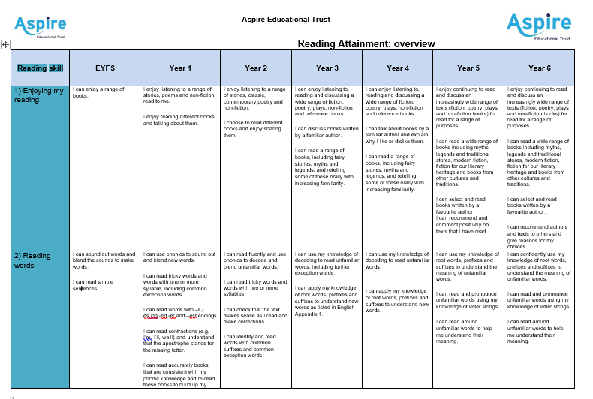
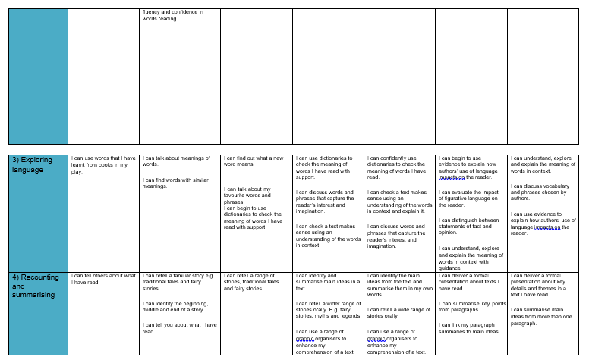
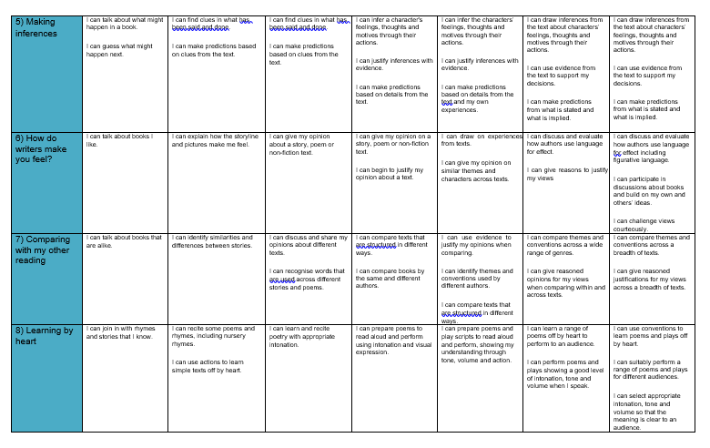
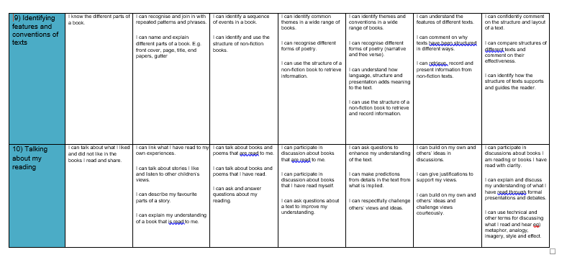

Y1 Non-statutory guidance
Pupil’s should have extensive experience of listening to, sharing and discussing a wide range of high-quality books with the teacher, other adults and each other to engender a love of reading at the same time as they are reading independently.
Pupil’s vocabulary should be developed when they listen to books read aloud and when they discuss what they have heard. Such vocabulary can also feed their writing. Knowing the meaning of more words increases pupils’ chances of understanding when they read by themselves. The meaning of some new words should be introduced to pupils before they start to read on their own, so that these unknown words do not hold up their comprehension.
However, once pupils have already decoded words successfully, the meaning of those that are new to them can be discussed with them, so contributing to developing their early skills of inference. By listening frequently to stories, poems and non-fiction that they cannot yet read for themselves, pupils begin to understand how written language can be structured in order, for example, to build surprise in narratives or to present facts in non-fiction.
Listening to and discussing information books and other non-fiction establishes the foundations for their learning in other subjects. Pupils should be shown some of the processes for finding out information. Through listening, pupils also start to learn how language sounds and increase their vocabulary and awareness of grammatical structures. In due course, they will be able to draw on such grammar in their own writing.
Rules for effective discussions should be agreed with and demonstrated for pupils. They should help to develop and evaluate them, with the expectation that everyone takes part. Pupils should be helped to consider the opinions of others
Role-play can help pupils to identify with and explore characters and to try out the language they have listened to.

Y2 Non-statutory guidance
Pupils should be encouraged to read all the words in a sentence and to do this accurately, so that their understanding of what they read is not hindered by imprecise decoding (for example, by reading ‘place’ instead of ‘palace’).
Pupils should monitor what they read, checking that the word they have decoded fits in with what else they have read and makes sense in the context of what they already know about the topic.
The meaning of new words should be explained to pupils within the context of what they are reading, and they should be encouraged to use morphology (such as prefixes) to work out unknown words.
Pupils should learn about cause and effect in both narrative and non-fiction (for example, what has prompted a character’s behaviour in a story; why certain dates are commemorated annually). ‘Thinking aloud’ when reading to pupils may help them to understand what skilled readers do.
Deliberate steps should be taken to increase pupils’ vocabulary and their awareness of grammar so that they continue to understand the differences between spoken and written language.
Discussion should be demonstrated to pupils. They should be guided to participate in it and they should be helped to consider the opinions of others. They should receive feedback on their discussions.
Role-play and other drama techniques can help pupils to identify with and explore characters. In these ways, they extend their understanding of what they read and have opportunities to try out the language they have listened to.

Y3/4 Non-statutory guidance
The focus should continue to be on pupils’ comprehension as a primary element in reading. The knowledge and skills that pupils need in order to comprehend are very similar at different ages. This is why the programmes of study for comprehension in years 3 and 4 and years 5 and 6 are similar: the complexity of the writing increases the level of challenge.
Pupils should be taught to recognise themes in what they read, such as the triumph of good over evil or the use of magical devices in fairy stories and folk tales.
They should also learn the conventions of different types of writing (for example, the greeting in letters, a diary written in the first person or the use of presentational devices such as numbering and headings in instructions).
Pupils should be taught to use the skills they have learnt earlier and continue to apply these skills to read for different reasons, including for pleasure, or to find out information and the meaning of new words.
Pupils should continue to have opportunities to listen frequently to stories, poems, non-fiction and other writing, including whole books and not just extracts, so that they build on what was taught previously. In this way, they also meet books and authors that they might not choose themselves. Pupils should also have opportunities to exercise choice in selecting books and be taught how to do so, with teachers making use of any library services and expertise to support this.
Reading, re-reading, and rehearsing poems and plays for presentation and performance give pupils opportunities to discuss language, including vocabulary, extending their interest in the meaning and origin of words. Pupils should be encouraged to use drama approaches to understand how to perform plays and poems to support their understanding of the meaning. These activities also provide them with an incentive to find out what expression is required, so feeding into comprehension.
In using non-fiction, pupils should know what information they need to look for before they begin and be clear about the task. They should be shown how to use contents pages and indexes to locate information.
Pupils should have guidance about the kinds of explanations and questions that are expected from them. They should help to develop, agree on, and evaluate rules for effective discussion. The expectation should be that all pupils take part.

Y5/6 Non-statutory guidance
Even though pupils can now read independently, reading aloud to them should include whole books so that they meet books and authors that they might not choose to read themselves.
The knowledge and skills that pupils need in order to comprehend are very similar at different ages. Pupils should continue to apply what they have already learnt to more complex writing.
Pupils should be taught to recognise themes in what they read, such as loss or heroism. They should have opportunities to compare characters, consider different accounts of the same event and discuss viewpoints (both of authors and of fictional characters), within a text and across more than one text.
They should continue to learn the conventions of different types of writing, such as the use of the first person in writing diaries and autobiographies.
Pupils should be taught the technical and other terms needed for discussing what they hear and read, such as metaphor, simile, analogy, imagery, style and effect.
In using reference books, pupils need to know what information they need to look for before they be The skills of information retrieval that are taught should be applied, for example, in reading history, geography and science textbooks, and in contexts where pupils are genuinely motivated to find out information, for example, reading information leaflets before a gallery or museum visit or reading a theatre programme or review. Teachers should consider making use of any library services and expertise to support this.
Pupils should have guidance about and feedback on the quality of their explanations and contributions to discussions.
Pupils should be shown how to compare characters, settings, themes and other aspects of what they read. They should be shown how to use contents pages and indexes to locate information.

