Holmes Chapel Primary School



Reading
Year 4
In class, your child will work with a range of text styles which are increasingly more difficult to help them continue to develop their skills as a reader.

When they are reading at home, they should ideally be choosing some material for pure pleasure and some material which stretches their reading. This may mean that sometimes they do not fully understand all that they are reading. This is where your child will benefit from your support. You can help overcome any misunderstandings by talking about what they read to you and even take your turn to read aloud. Reading aloud with your child helps you to model pace, expression and fluency for your child.

By the end of Year 4 most children will be able to…

- Recognise a range of common prefixes, suffixes and regular verb endings to construct the meaning of words in context.

- Understand how dialogue is punctuated, laid out and read with appropriate expression.

- Use of bibliographic knowledge, e.g. indexes to scan texts and locate specific information.

- Understand narrative order and chronology, tracking the passage of time in stories.

- Understand how to use indexes to locate specific information.

- Understand how chapters and paragraphs are used to collect, order and build up ideas.

- Interpret the effect of the language chosen by the author.

- Evaluate the usefulness of information – e.g. follow instructions to see if they work.

- Begin to practise locating sources of information.

- Sustain silent reading to include longer more complex texts.

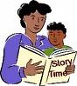
How can you help your child?

There are many ways you can help your child to develop in their reading.

- Try to spend time talking to your child about what they are reading. 15-20 minutes four times a week is much better than longer sessions once a week.

- Find a quiet place to share books where you can be comfortable.

- Talk about the book. You will find a list of suggested questions and ideas to encourage your child to talk about the book on the back of this leaflet.

- Ask questions which encourage your child to give their own opinions for example:- Do you agree with this/the author’s opinion? How do you feel about this topic? Why? What do you think about/is your opinion of…? Can you support your view with evidence from the text?

- Encourage your child to read a range of texts such as newspapers, comics, poetry, non-fiction, etc.

- Share a book with your child. This may involve you reading to them or reading and talking together about the book.

- Play word games.

- Encourage children to read a series of books from a favourite author or books on topics of interests especially to keep reluctant readers interested in reading.

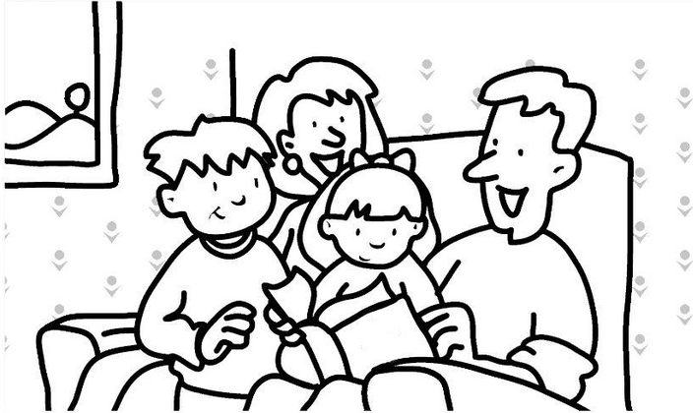
Questions you could ask your child during reading

Fiction
- Who was the character that…?
- Show me in the text where you found…?
- What is happening at this point/in this part of the story?
- Find one/two things that the main character did in this part of the story.
- Why was…important in this story?
- Tell me/write about what sort of character/person…was from the things they did/said in the story.
- What do you think…thoughts were at this point in the story/play? Use the text to help you think through your answer.
- If you were going to interview one of the characters, which questions would you ask and why?
- How did one of the characters change their ideas/ attitudes during the story/play? What was it that brought about this change?
- What do you think would have happened if…?
- Tell me about one important event that happened that could not be left out. Why is it so important?
- If…had not done…, how might this have changed other events in the story?
- How has the author organised the writing?
- Why does the author begin a new paragraph here?
- What is/are the main event(s) that happen(s) in this/ each paragraph?
- How has the author used words/phrases to make this character funny/sad/adventurous/clever/frightening/ excited/disappointed, etc?
- Which part of the story best describes the setting/ characters/action? Which words and /or phrases do this?
- Find and copy some words or phrases that show us that this character is special/helpful/adventurous/ unsure/worried, etc.
- How did the story make you feel? Why did it make you feel like this?
- Why do you think the author chose this particular setting for this story?
- How has the author started this in an interesting way. How does this make the reader want to read on?

Non- Fiction

- Where can you find an important piece of information about …?
- Find two pieces of information that tell you about …?
- What does this part of the text tell us about ….?
- Which part of the text tells us about …?
- How does this text layout help the reader?
- How does (a diagram/picture/caption) help you to understand the information on this/these pages?
- What is the purpose of the list/diagram/caption/ sub-headings in this text?
- Find something that is not a fact but the author’s opinion.

