**Holmes Chapel Primary School**



**How to use Microsoft Teams**

**Simple guide for parents and children**

This guide is to support parents and children downloading and using Microsoft Teams. MS Teams is a video and audio meeting space that children can join to talk to their teacher and class. It is also a digital platform for storing, uploading and downloading work for school.

Contents:

Page 2: Software and Login

Page 3: Teams and Channels

Page 4: Assignments

Paeg 5: Joining a Meeting

Page 6: Calendar

This is a basic guide to Teams. We may gradually introduce further applications within Teams and within Office 365 over the year. If you have any questions, please speak to your teacher or contact Mrs Brown on senco@holmeschapelprimary.cheshire.sch.uk

**Software and Login**

Before using Teams, you can download the desktop or mobile app.

Or you can use your browser on a computer using this link:

<https://www.microsoft.com/en-gb/microsoft-365/microsoft-teams/log-in>

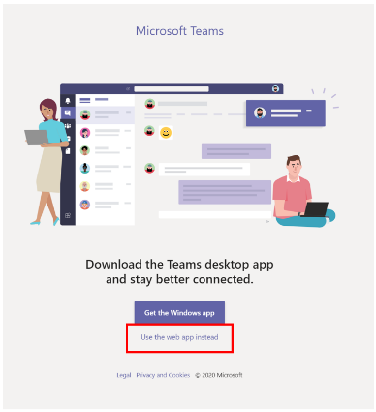



Once downloaded or on the website, type your email address and password as supplied by school.

This is in the format of firstname.surname@holmeschapelprimary.cheshire.sc.h.uk

e.g. joe.smith@holmeschaepelprimary.cheshire.sch.uk

Your password cannot be changed. Please keep it safe and do not share it with your friends.

**Different Teams**

When you are logged in you will see this screen below. Click on the icon Teams on the left hand side of the screeen and you will see the Teams you are now assigned to.

This is what Mrs Brown’s looks like but children should only be part of one or two Teams e.g. Year 3 or Class 3A.

**PLEASE do NOT** Create a Team as we need to be able to monitor all Teams from school.

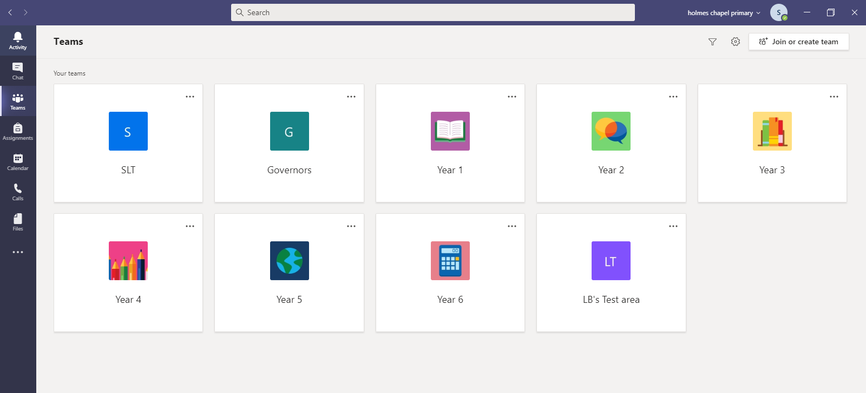

**Channels in Teams**

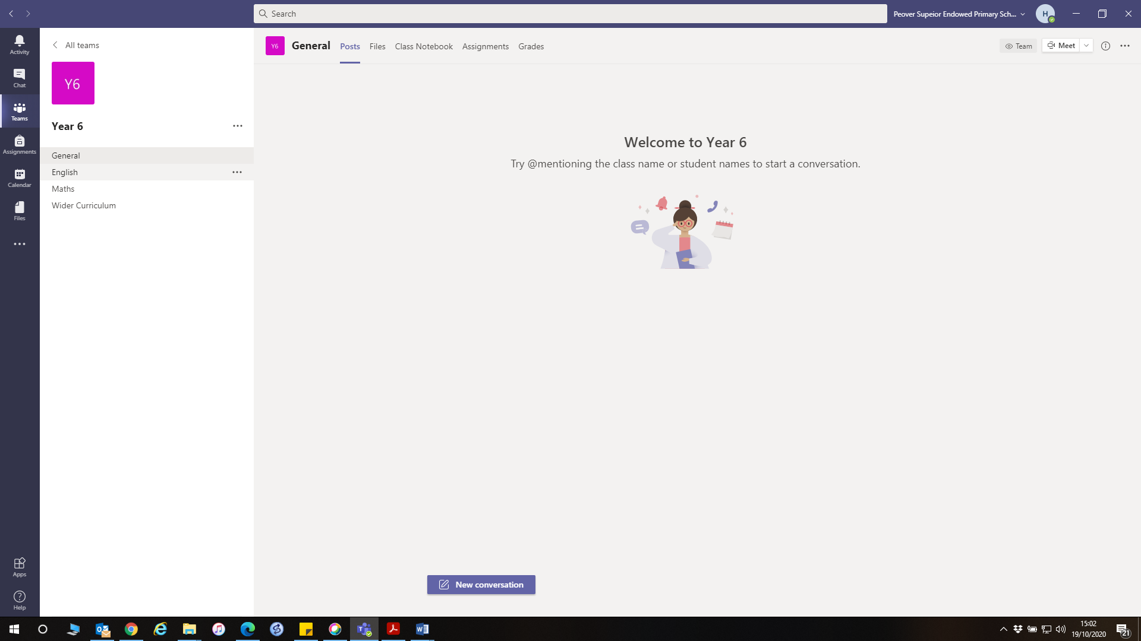

Click on your Team e.g. Year 6 to open the Team. You will see this screen (see above). On the left-hand side, there are now different channels. The chat function on Teams is not available for you to use.

If you click on the ‘Posts’ button, you can see any posts, comments and documents shared by your teacher as well as any live meetings that you can join. Only adults can post on the channel.

**Assignments**

At the left side of your screen there is a tab called assignments. This is where you will find some of the work set by your teachers. Some of these can be completed on your device so you do not need to print anything out.

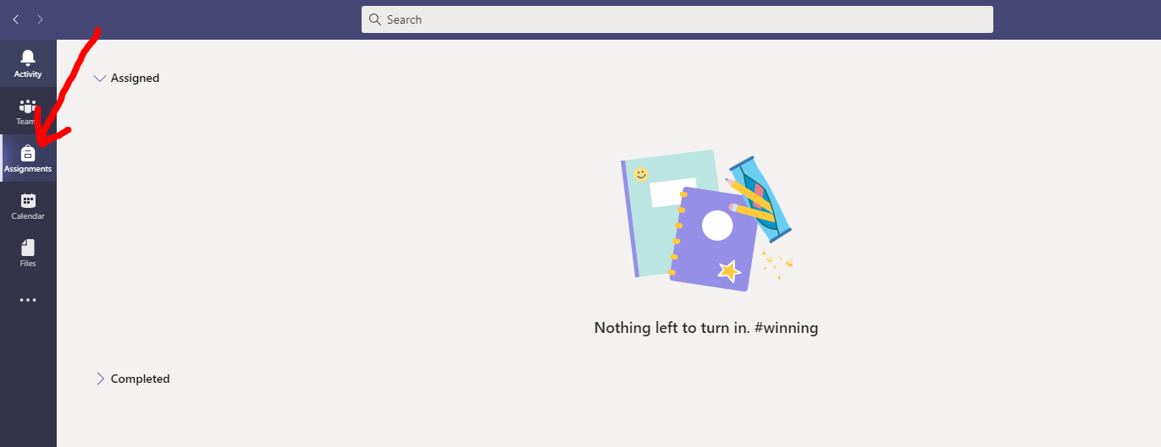

It will show you if you have any work due to be completed in the **Assigned** section and any work that you have **Completed**.

When you click on an assignment, it will give you information about what to do and when you should complete your work by.

You should be able to complete your work on the Teams screen, but if you want to you can download it, print it out and do it on paper.

When you have finished, click **Turn in** and the work will be sent directly to your teacher, where they can read it and add any comments. They can then send it back to you for you to read their feedback.

If you want to send in a picture of the work you have written, that can be uploaded instead.

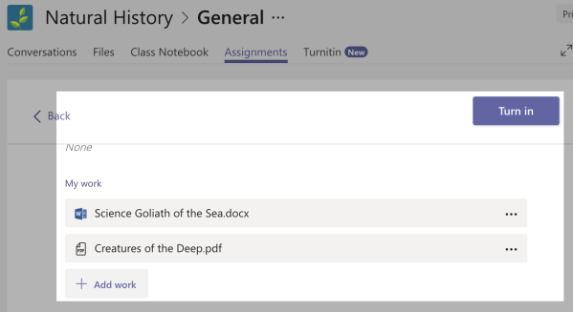

**Joining a Teams ‘live’ meeting**

Children cannot start a live meeting as this feature has been turned off.

When it is time to join a Teams meeting and you have been told to join by your teacher, this is what you will see in the corner of your Teams area. Click **Join.**

Please don’t join a meeting unless you have been told to by your teacher or TA.

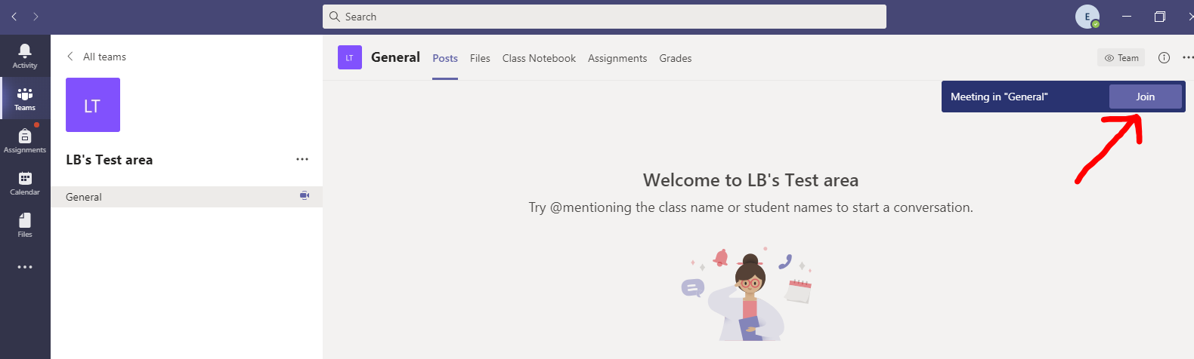

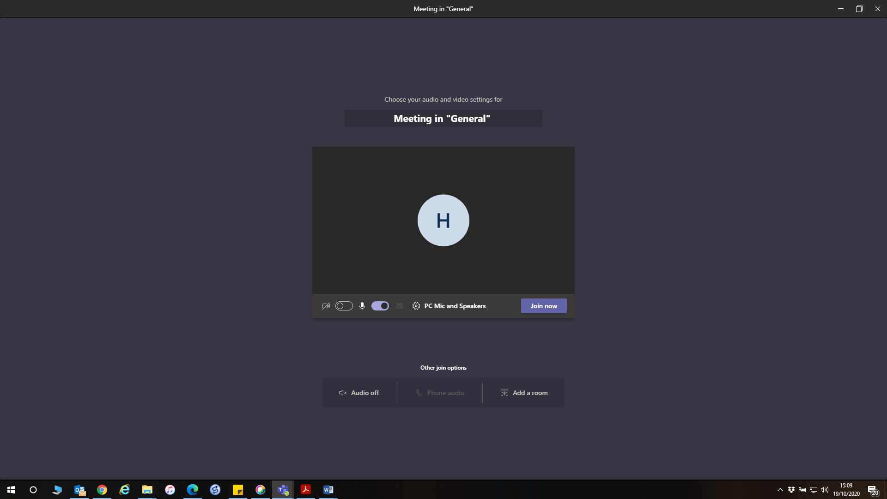

When you join a meeting, you will be added to a lobby and an adult will let you in at the correct time.

When joining a Teams meeting, you can turn off your video and audio. Your teacher can also do the same. The initials or name of the person currently talking will be shown on the screen. Teachers can also share power poimts, videos etc through Teams.

If your teacher has muted you all so that they she/he can talk, you can also press a message icon on the screen. This is the class chat that can be used during live sessions. **Please use this appropriately**, as mentioned in the Code of Conduct for online sessions. Do not type anything that you wouldn’t feel is okay to say aloud in class.

**Calendar**

Your teacher may use invites and the calendar to set up meetings, or they may just ask you to login at a set time and to click the **Join** button as shown in the previous section.

If you have a scheduled meeting, you can see this in the calendar tab at the left side of the screen. You can also join a scheduled meeting from this tab.

Children are unable to create their own New Meeting.

When you join a meeting, you will be added to a lobby and adult will let you in at the correct time.

