Home choosing activities w/c 13/7/20
Air Balloon Challenge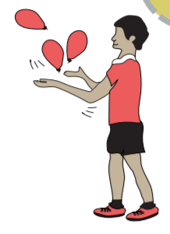  Can you keep the balloon up in the air for 60 seconds?  If you do not have a balloon, use scrunched up tissue paper or a bag! | Create your own word search  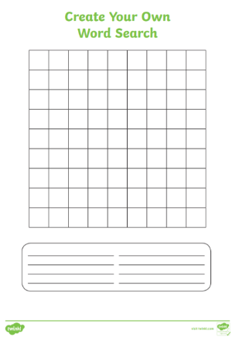  Create your own word search with the phase 3 tricky words | Mindfulness Doodling  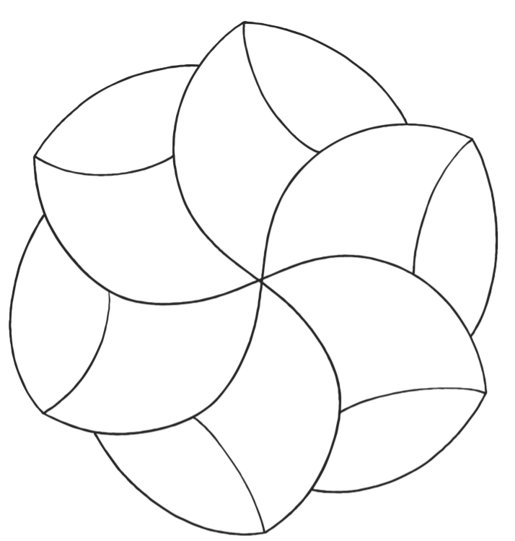  Use the mindfulness doodling sheets to do some designs and colouring. Adults see the adult guidance sheet to help you to instruct your child what to do. | Ordering Cups  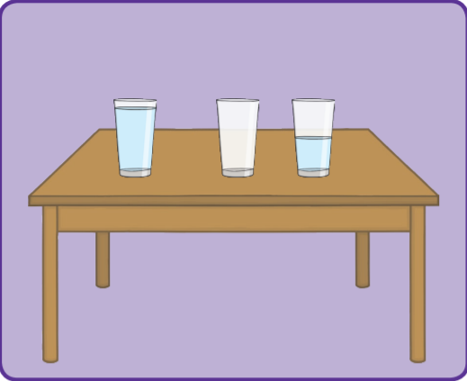  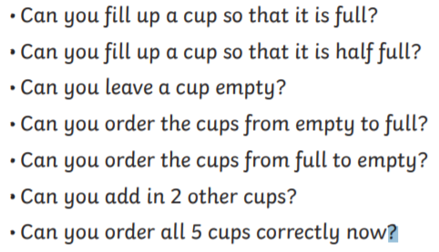 | Dream House  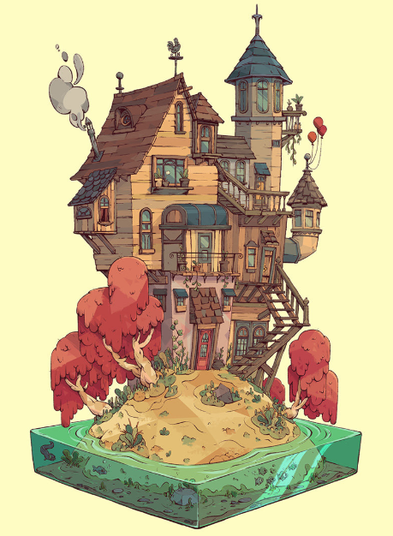  Can you design your dream house?  How many rooms would it have?  What would the rooms be?  Who would live in it?  You can draw it, paint it or even make it with junk/ lego/etc.
Create a Fairy Garden  Create an enchanted garden at the base of a tree or in a hollow in the ground. Collect stones for paths and twigs for fences and you could small plants around the trunk. Tie ribbons to branches and make a fairy door for a tree or wall by decorating a piece of cardboard or the lid of an ice-cream tub. | Create your own board game  Create your own board game with maths and / or phonics questions.  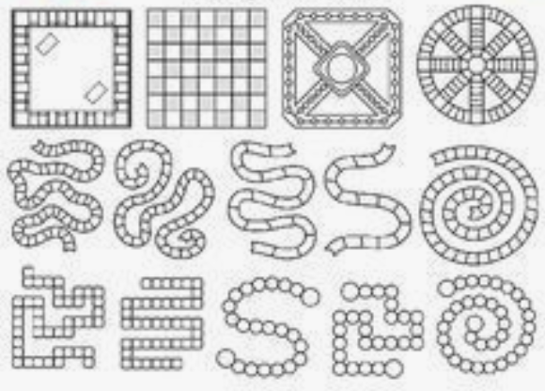 | Footy Pups  Learn some new sports skills with Footy Pups.  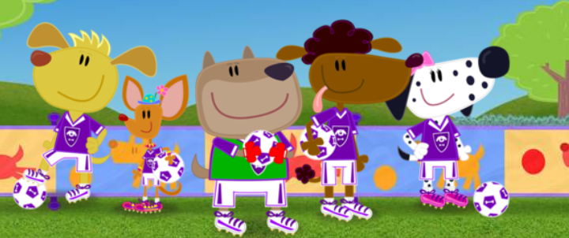  https://www.bbc.co.uk/cbeebies/curations/footy-pups-super-skills | Constructing Shapes  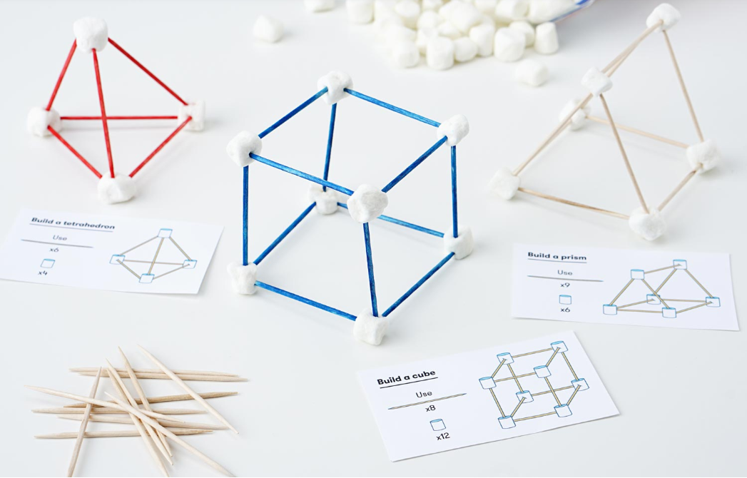  https://s3-us-west-1.amazonaws.com/acropolis-wp-content-uploads/construction-activities-constructing-shapes.pdf | OXFORD OWL  Visit the Oxford Owl website to try some of the their fun activities or listen to someone read a story to you.  https://home.oxfordowl.co.uk/kids-activities/?gclid=Cj0KCQjw0YD4BRD2ARIsAHwmKVknEJbFkHiq23hlMzcYl6UvjTpPaaawIAxRc1fnnhKVluvChp2zQhUaApdLEALw_wcB

USEFUL WEBSITES
See the VLE pages for all the website links to reading sites, keeping active, etc.

