Home choosing activities w/c 6/7/20
Body Percussion  Try making different sounds with your body:  Clap your hands  Stomp your feet  Pat your thigh  Click your fingers  Now try making a repeating pattern with your sounds. | Weather recording  We have had lots of different types of weather in the last few weeks.  Over the next week, can you record what the weather is like each day?  Make a weather chart and write the days of the week on it. Each day, draw a picture and write what the weather is like. How many different types of weather have we had?  You could even make your own rain gauge to find out how much rain has fallen in a day. 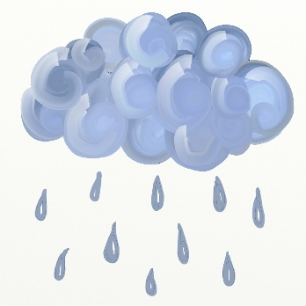 | Tin Can Alley  Use any small ball you have and see how many of the tins you can knock over.  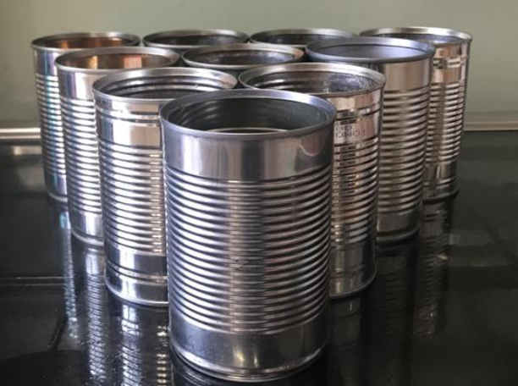 | Mini Beast Adventure  There are lots of different mini beasts outside at the moment.  Can you go out looking for some and draw what you find?  Perhaps you could find out about the life cycles of one of your mini beasts.  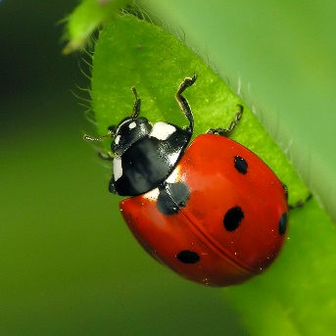 | Building towers  Can you make a tower taller than you?  Think about what you will use to make it a tall tower.
Technology Hunt  Have a look around your house. Can you find all the things that need buttons to make them work? | Bake sports day medal cookies  Follow the recipe to make medal cookies.  https://www.bbcgoodfood.com/recipes/medal-cookies | Time Traveller  Ask Mum/Dad/Grandparents to show you old photos of themselves and family members. Ask them to talk to you about them. How have people changed? What was different when they were younger to now? | Write an email to your teachers  Ask an adult to help you to write an email to your teachers to tell them what you have been doing this week?  classr@holmeschapelprimary.cheshire.sch.uk  classra@holmeschapelprimary.cheshire.sch.uk | OXFORD OWL  Visit the Oxford Owl website to try some of the their fun activities or listen to someone read a story to you.  https://home.oxfordowl.co.uk/kids-activities/?gclid=Cj0KCQjw0YD4BRD2ARIsAHwmKVknEJbFkHiq23hlMzcYl6UvjTpPaaawIAxRc1fnnhKVluvChp2zQhUaApdLEALw_wcB

USEFUL WEBSITES
See the VLE pages for all the website links to reading sites, keeping active, etc.

