Welcome to Reception
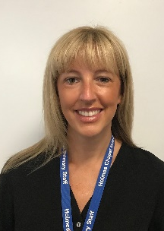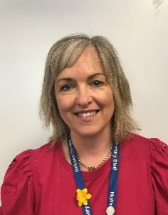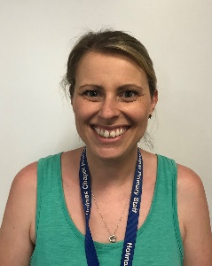
Mrs Noble Ms Lackford Miss Wootton Mrs Morris Mrs Cochrane Mrs Walker
Class R Teacher: Mrs Noble
Class Ra Teachers: Ms Lackford (Monday – Wednesday) and Miss Wootton (Wednesday – Friday)
Reception Teaching Assistants work across both classes
Mrs Morris (Monday- Friday), Mrs Cochrane (Monday – Wednesday) Mrs Walker (Wednesday – Friday)
Mrs Lal and Mrs Cookson: Welfare assistants

What is the best way to contact us at school?
If you would like to contact class teachers, please leave a message with the office by phone or email and they will pass it on. Please use the office email for urgent emails as this is checked more regularly. Morning drop offs and afternoon pick-ups are very busy, so this is not an ideal time to pass on information.
School office admin@holmeschapelprimary.cheshire.sch.uk
Class R (Mrs Noble) classr2021@holmeschapelprimary.cheshire.sch.uk
Class Ra (Ms Lackford and Miss Wootton) classra2021@holmeschapelprimary.cheshire.sch.uk
If you have something that you would like to discuss with a member of the school leadership team, please contact Mrs Williams (Key Stage 1 lead), or Mrs Brown (Deputy Head).
Mrs Brown is also our Special needs coordinator and Mrs Lavin is our learning mentor, should you need to contact them directly.

What is the daily routine?
School gates on Jubilee Walk will be opened at 8:40 to allow parents and children onto the playground. The classroom doors will open at 8:50. When Reception staff come out, please leave your child at the wooden gate on the playground, where they will be shown into the classrooms.
At 3.15, children will be brought to the same gates on the playground, where we will hand them over to their adult. Please keep an eye out for your child and give us a wave if we don’t recognise you at first! If someone else is collecting your child at the end of the day, please inform the office, as we can’t release them to a ‘strange’ adult, if we haven’t been informed.
If your child is going to an after-school, or childminder please let us know via email and make sure your child is aware of where they are going each day.
Please note that no scooters, bikes, or dogs are allowed on the playground.
Healthy snacks and water bottles (toast will be available for Reception children from 15th September – 20p per slice. Children should send £1 in a named envelope on Monday for a slice of toast each day of the week
There are children in school with severe nut and dairy allergies, please be mindful about this.

What does my child need to bring to school?
A named water bottle (only containing water not juice).
A healthy snack (optional as free fruit is also provided).
Their plastic reading folders (These will be given out once we have done our initial assessments and allocated reading books).
A coat every day.
If your child brings a bag it needs to be of a reasonable size to fit our small cloakroom areas. School blue bags are preferable.
Children should not bring in toys from home.
What is covered in the curriculum?
Each day, your child will have a Phonics, Literacy and Maths input. Initially we will be doing baseline assessments with all children individually. We will then stream the children into 4 phonics groups. Maths and Literacy will be taught whole class, but small group provision will also be made where necessary, when children are identified as needing further support.
The Early Years Framework incorporates seven areas of learning, which are delivered through direct teaching, independent learning opportunities and child initiated activities.
Our PE day in Reception is Friday. Every Friday, please send your child into school wearing PE kit (ensuring they have warm outer clothes, suitable for playtime). Children should have named, black PE pumps, which they will keep in school. Please see the school uniform list for more information.
Black trainers can be worn everyday with school uniform.
We use technology regularly in the form of Ipads and laptops and as part of that, we provide an introduction to e-safety.
Reading books
The children will bring home books on a Wednesday and should be returned to school on a Tuesday in their reading folders.
They will bring home;
- Two ‘basket books’ These are picture books that the children have selected and are to be shared with an adult.
- 1 banded book. These are aligned to your child’s reading/phonics ability, which will be assessed regularly.
- Please read every night at home. We encourage re-reading books to build fluency and confidence.
- Please record in the yellow reading diary books when you have read at home. This does not need to be a lengthy comment!
Our new school rules to promote positive behaviour are:
- We look after each other
- We look after our school
- We try our best

What else do we need to know?
- Every Friday we will put a brief outline on the VLE of what we will be covering the following week and photos of what we have been doing that week. Please check the gallery links on the Reception page.
- Please ensure you have completed your photo consent form and handed it in to the office, otherwise we will not be able to include photos of your child.
- Parents’ evenings will be held towards October half term and spring half term. These may be virtual, so dates and further information will follow.

