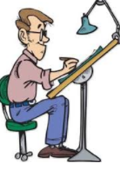HCPS Engineering Challenge 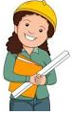
Calling budding designers!

Do you enjoy designing and creating?
Enter our engineering challenge.

There is a challenge for KS1 and one for KS2.
You can work with a friend or sibling.
Once you have finished your creation, please take a photo to bring into school.
KS1 - please measure how tall your tower is.
KS2 – please time how long your marble runs for.
Winners will be chosen for each challenge.
We look forward to seeing your creations!!

Deadline for entries 2nd March 2018

Parents please support your child appropriate to their age and level of skill but we would like the designing to be your child’s own.

Engineering challenge
WHAT’S AN ENGINEER? Engineers dream up creative, practical solutions and work with other smart, inspiring people to invent, design, and build things that matter. They are changing the world all the time.
KS1 Challenge
What is the tallest tower you can build from 6 sheets of broadsheet newspaper? You can use sticky tape, glue or string.
Can your tower support the weight of a small beanie toy?
Think about different ways you can use the paper, for example bending, rolling, tearing, scrunching or concertina folding (think of a fan!)

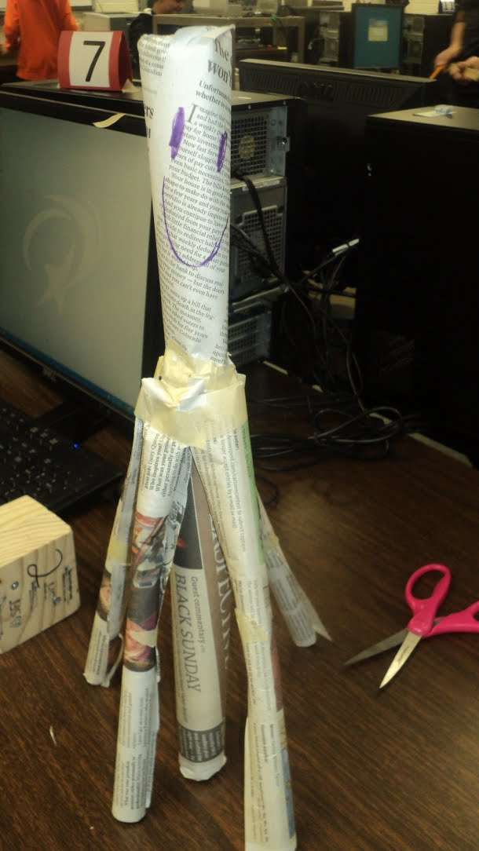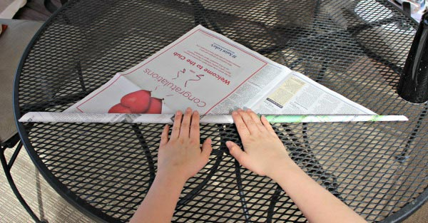

Engineering challenge
WHAT’S AN ENGINEER? Engineers dream up creative, practical solutions and work with other smart, inspiring people to invent, design, and build things that matter. They are changing the world all the time.
KS2 Challenge
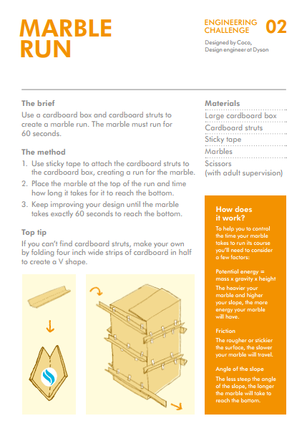
The winning run will be the one which runs for longest.

