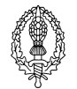
Year 5 Art and Design Curriculum

 | Year 5 | Art activities to cover skills | Artists - please highlight artist studied | End of year expectations
Art Appreciation | To research and discuss the ideas and approaches of great artists, architects and designers and understand that their work was shaped by the historical and cultural context in which it was created. | - Sketch books are introduced in Year 1 even though this is not a requirement of the NC  - See school document ‘HCPS Art and Design – Guide to using sketchbooks  - Great artists, architects and designers are studied throughout the Year 5 art curriculum | Georgia O’Keefe  Ancient Islamic art and artists and architecture – link to William Morris  Linda Caverley | I know which approaches specific artists, architects and designers use and why.  I know how to work in a similar way to artists I have studied.  Know how to use sketchbook to develop ideas for/of artwork  I know how to develop my own artistic techniques through the study of artists, architects and designers.
Drawing  pencil,  charcoal,  inks,  chalk,  pastels,  ICT software | -Effect of light on objects and people from different directions  -Interpret the texture of a surface  -Produce increasingly accurate drawings of people  -Concept of perspective | Autumn 2 Drawing Viking artefacts – borrow from the Library Service. Look at light etc on the artefacts and how light falls from different directions. Interpret texture developing skill of ways in which surface detail can be added to drawings taught in Year 4. Look at work by artists on how they draw still life objects. Mix a suitable media such as pencil and charcoal, pen and inks.  Why this? Why now? This follows Year 4 drawing of a Roman helmet and builds on the skills taught then. The children will continue to develop their skills of using different media  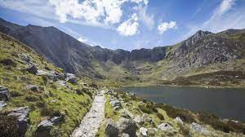  Spring 2 Develop use of perspective in landscapes. Look at the reasons why artists use perspective so that pictures appear 3D. Two types of perspective – linear and aerial/atmospheric perspective (which Georgia O’Keefe uses). Use photographs to show both types. Draw linear and will come back to aerial/atmospheric when go onto GO’K work  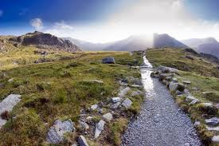  https://www.tate.org.uk/art/student-resource/exam-help/perspective  https://www.somerford.dorset.sch.uk/wp-content/uploads/2020/06/Drawing-Perspective-PowerPoint-for-art.pdf  Why this? Why now?  Spring 2 GEORGIA O’KEEFE UNIT OF WORK  - By studying landscapes by Georgia O’Keefe, the children will create their own by drawing in shapes by using pastels or charcoal. First, sketch the outline of hills, mountains and trees. Some go in the foreground, and they keep going further into the background. In layers. Next begin colouring the spaces in. At first, just use the pastel lightly and fill in the spaces. Can start by using the darker colours first, and pressing harder, filling in the areas that need it with a nice thick layer of colour. Press on with adding more colour. Build up a heavy coat of pastels, so that it can be scratched away to add some details later on. Once everything is covered can use a dark pastel to add some outlines if wish. Using the toothpick scratch away some of the pastels to create a more detailed piece of art. Add tree branches, grass, highlights, outlines, clouds and more.  - https://www.happyfamilyart.com/art-lessons/art-history-for-kids/georgia-okeeffe-art-history-lesson-for-kids/  - Use different media to make marks and lines in dry media – digital mark making, pencil, charcoal, oil pastels  - Explore colour mixing and blending with pastels  - Apply the effect of light on objects from different directions  - Begin to use perspective in work using a single foci point and horizon - GO’K work  https://www.tate.org.uk/kids/explore/who-is/who-georgia-okeeffe  Why this? Why now? This unit will coincide with the Year 5 residential that includes a field trip into the Snowdonia National Park and Geography topic on Mountains. It will develop skills on perspective, drawing, using different media and techniques. | Leonardo  Da Vinci,  Vincent  Van Gogh,  Poonac  Georgia O’Keefe | Know how to use a variety of source material for their drawings.  Know how to work from observation, experience and imagination.  Know how to make informed choices in drawing including paper and media and the visual elements: line, tone, pattern, texture, colour and shape.  Use the correct terminology for drawing materials they have selected.  Know how to select and mix suitable media within a single piece to create different effects.  Know how to use shading and tone to add depth and shape to their drawings.  Know how to use line to create movement in a drawing.
Colour  painting,  ink,  dye,  textiles,  pencils,  crayons,  pastels | -Hue, tint, tone, shades and mood  -Explore the use of texture in colour  -Colour for purposes | - Identify and work with complementary and contrasting colours using different media – paint, pastels etc  - Mix and match colours to create atmosphere  - Use a variety of tools to create texture  - Autumn 2 Digital art front covers – search and find a picture of a Viking artefact for example. Import into a MSWord document and use the colour and artistic effects. Discuss with the children the choosing colour for a purpose and use of texture  Why this? Why now?  Mountain artwork inspired by Georgia O’Keefe- Spring 2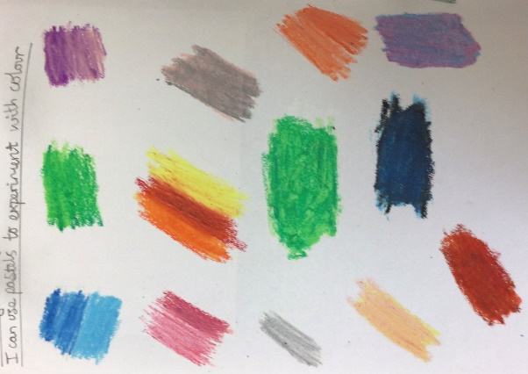 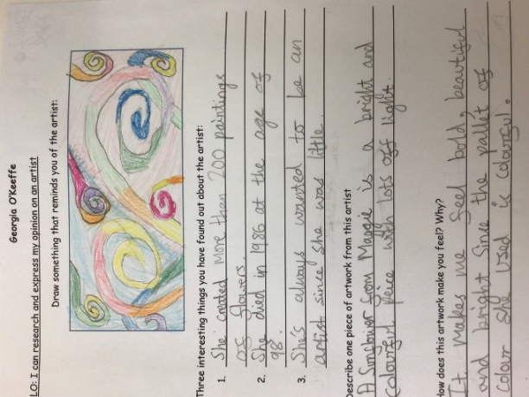  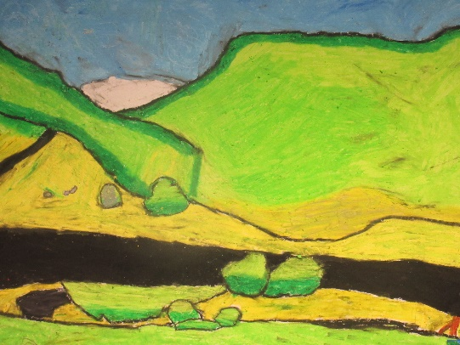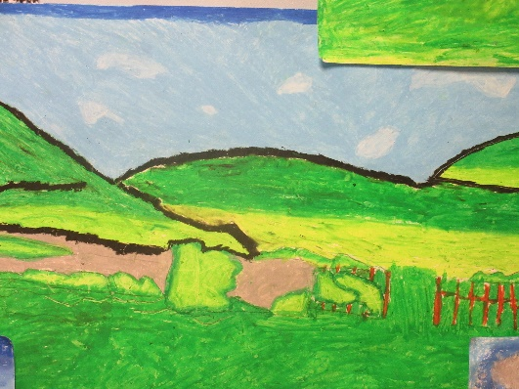  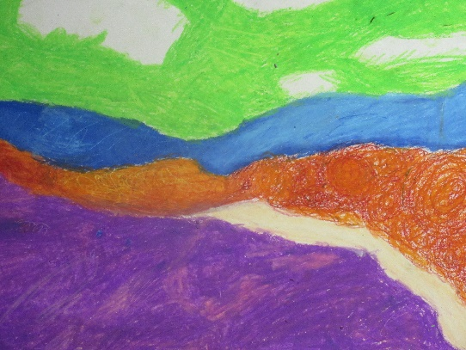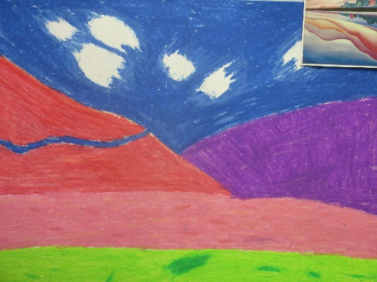  Why this? Why now? This unit will coincide with the Year 5 residential that includes a field trip into the Snowdonia National Park and Geography topic on Mountains. It will develop skills on perspective, drawing, using different media and techniques. | Pollock,  Monet,  Chagall,  Ben Moseley,  Van Gogh,  Georgia O’Keefe | To know that complementary colours are directly opposite each other on the colour wheel.  To know how to describe an exact colour eg: hue – describes the colour within a spectrum, tint, tone and shade.  To know how to select and mix suitable media within a single piece, justifying their selection.  To know how to work from observation, experience and imagination.  To begin to develop own painting style.  To use the correct terminology for painting materials they have selected.
Texture  textiles,  clay,  sand,  plaster,  stone | -Use stories, music, poems as stimuli  -Select and use materials  -Embellish work  -Fabric making  -Artists using textiles | - Identify and work with complementary and contrasting colours using different media – paint, pastels etc  - Mix and match colours to create atmosphere  - Use a variety of tools to create texture  - Mountain artwork inspired by Georgia O’Keefe- Spring 2  Texture applied by scratching into pastels with various implements  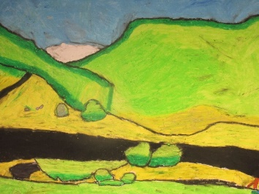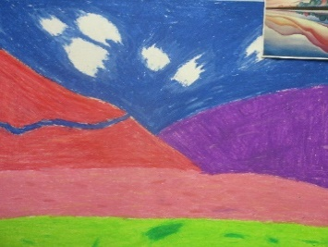  Why this? Why now? Texture is developed by scratching into the surface.  Summer . Create a clay slab bowl and add relief to it in the form of Islamic patterns – Golden Age of Baghdad. Focus on Arabesque (an artistic decoration. It uses "surface decorations based on... interlacing foliage, tendrils" or plain lines. Another definition is "Foliate ornament, used in the Islamic world, typically using leaves... combined with spiralling stems") and Calligraphy. Look at how the Golden Age of Bagdad led to the development of art and how it influenced art and architecture throughout the Islamic world. Link to William Morris whose work was also inspired by nature.  Step 1. Taking in - Look at the work of ancient Islamic artists and William Morris. Respond in sketch books to pictures of the different art.  Step 2. Testing out - Create own designs in sketchbooks.  Make slab bowl https://ceramicartsnetwork.org/daily/article/Simple-Sets-Making-and-Using-Slab-Bowl-Templates  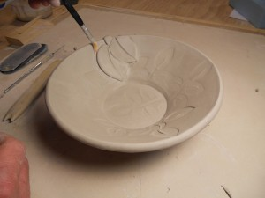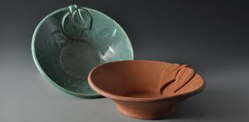  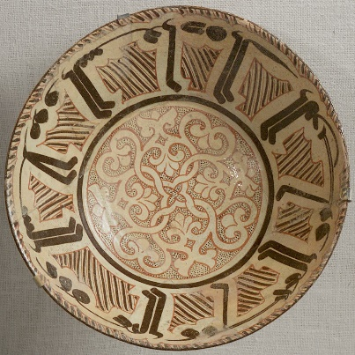  Step 3. Reflecting – Take photos of the children’s work and children to reflect on their work in their sketchbooks.  https://courses.lumenlearning.com/suny-hccc-worldcivilization/chapter/the-islamic-golden-age/  https://www.ducksters.com/history/islam/art.php  Look at work of modern day Islamic artists and make comparisons between the ancient and the modern. What is the same? What is different? Children to respond in sketchbooks to examples of both.  https://www.ifdcouncil.org/5-of-the-most-awe-inspiring-islamic-artists/  Why this? Why now? The children study the Golden Era of Baghdad which was a very important time because a distinctive style emerged and new techniques were developed that spread throughout the Muslim realm and greatly influenced Islamic art and architecture.  Clay. This builds in the work in Year 3 where they created a tile using a slab of clay and added decorations using a variety of techniques - practise rolling out and cutting out a tile, scratching into a surface, rolling out very thin worm-like strands, rolling small bobbles, attaching relief elements to the tile, adding texture and depth with tools. Year 5 revisit these skills and develop it further by joining two large sections together to create a bowl. The relief work is added later. | Linda Caverley, Molly  Williams, William Morris,  Gustav Klimt  Early Islamic art and architecture | Know how to create a plan for a 3D form, responding to a stimulus  Know which materials and tools are most appropriate for the purpose  Know how to review and revisit ideas - making suitable adjustments during construction and justifying their decisions in a final evaluation.
Form  3D work,  clay,  dough,  boxes,  wire,  paper sculpture, mod roc | -Plan and develop ideas  -Shape, form, model and join  -Observation or imagination  -Properties of media  -Discuss and evaluate own work and that of other sculptors | - Shape, form, model and construct from observation and imagination.  - Natural objects artwork on residential- Spring 2  Children to use natural materials to create the natural landscape around them whilst on a walk in Snowdonia. Andy Goldsworthy to be studied prior to trip.  - Goldsworthy homework set within grid menu- Spring 2  - Clay pots Summer  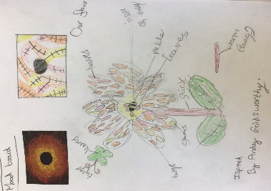  Why this? Why now? As part of their residential, the children have a field trip to Snowdonia where they go on a walk in the Idwal valley. As part of the walk, they will be able to observe the natural landscape and create a model. They will photograph this and will print the photos to put into their sketchbooks and respond to it. | Henry Moore, Barbara  Hepworth, Andy  Goldsworthy, | Know how to create a plan for a 3D form, responding to a stimulus  Know which materials and tools are most appropriate for the purpose  Know how to review and revisit ideas - making suitable adjustments during construction and justifying their decisions in a final evaluation.
Pattern  paint,  pencil,  textiles,  clay,  printing | -Create own abstract pattern to reflect personal experiences and expression  -Create pattern for purposes | - Patterns explored for Christmas cards- Autumn 1  Children to use black and white patterns to build up an abstract Christmas tree on top of a watercolour wash. Link to Linda Caverley  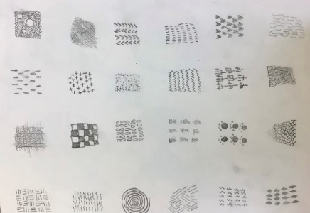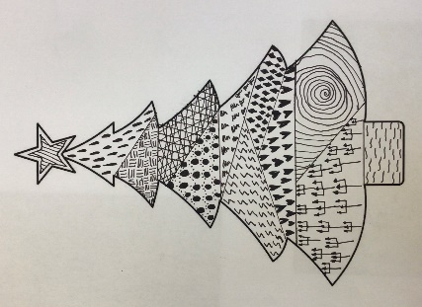  Why this? Why now? Children develop their knowledge and understanding of pattern and make deliberate choices when developing their own ideas. The pattern making has purpose as it is going to be made into a product (PTA fund raising)  Pattern is developed through the study of the work of Andy Goldsworthy, Georgia O’Keefe and the clay pots. | Joan Miro, Bridget Riley, Escher,  Paul Klee,  Linda Caverley | Know how to create own abstract pattern to reflect personal expression  Know how to create pattern for purposes

