Year 4 Art and Design Curriculum

 | Year 4 | Curriculum | Artists - artist studied | End of year expectations
Art Appreciation | To describe some of the techniques used by great artists, architects and understand that their work was shaped by the historical and cultural context in which it was created. | - Sketch books are introduced in Year 1 even though this is not a requirement of the NC  - See school document ‘HCPS Art and Design – Guide to using sketchbooks  - Great artists, architects and designers are studied throughout the Year 4 art curriculum | Ancient Greek pottery  Monet  Van Gogh  John Muafengejo | Know how to describe a piece of work, identifying the inspiration taken from famous artists, architects and designers.  Know how to use images and information independently to inform their own drawing in their sketchbooks.  Know and describe some of the starting points, processes and techniques used by great artists, architects and designers in history.  Know how to express an opinion on the work of famous, artists, architects and designers, referring to techniques and effect.
Drawing  pencil,  charcoal,  inks,  chalk,  pastels,  ICT software | Identify and draw the effect of light  scale and proportion  -Accurate drawings of whole people including proportion and placement  -Work on a variety of scales  -Computer generated drawings | Autumn 2: Identify and draw the effect of light  Series of lessons on light and shade, culminating in the drawing and shading of a Roman helmet – using the helmet to show shape (3D).  (light and shade)  Why this? Why now?  Links to the Roman topic. Brings together the skills of drawing light and shade and are then able to apply to a real life model. Children to use different grades of pencil.  Autumn 1: Greek vases created from paper  -scale and proportion  -Accurate drawings of whole people including proportion and placement  -Work on a variety of scales  Creating Greek vases. Studying the shape of different vases and sketching these. Drawing figure outlines in different positions with a focus on proportion. Selecting a particular figure and position to draw onto a Greek vase outline. Studying and sketching Greek patterns to add to the vase. Design own figurine to go onto vase linked to Olympics and Greek myths. Able to focus on the shape of the body and proportion.  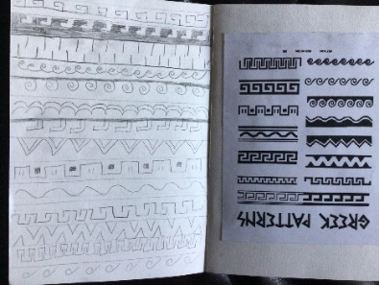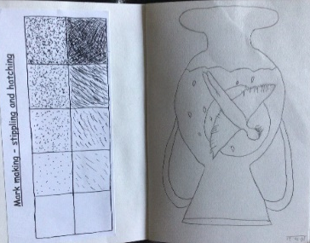  Why this? Why now?  Links to Greek topic and gives the children the opportunity to concentrate on figurines without the pressure of the detail.  Spring 2??? Could loose this if needed???!!??! OR DO A PART OF PREPARATION FOR PRINTING LOOKING AT PATTERNS ON ANIMALS  make marks and lines with a wide range of drawing implements, chalk pastels, pencils, fine liners, felt tips, paint  apply and use simple pattern and texture to a drawing  show an awareness of objects have a third dimension  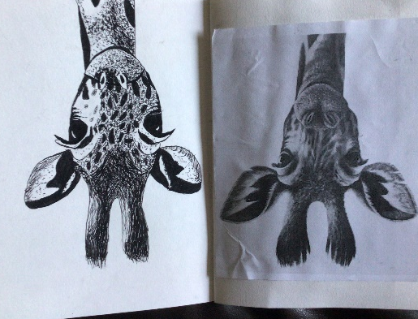  Why this? Why now?  Use a variety of techniques and pens of differing thicknesses. Use cross-hatching, stippling to create texture, light and shade. Look at how to add surface detail to a drawing. Develop skills in using a variety of tools - pen | Leonardo  Da Vinci,  Vincent  Van Gogh,  Poonac  Greek pottery  BAME artists | Know why they might use different grades of pencils in their drawing and what effects can be created.  Know how to alter and refine their drawings and describe the changes they have made using art vocabulary.  Know ways in which surface detail can be added to drawings.  Know about the relationships between line and tone, pattern and shape, line and texture.
Colour  painting,  ink,  dye,  textiles,  pencils,  crayons,  pastels | Colour mixing and matching; tint, tone, shade  -Observe colours  suitable equipment for the task  -Colour to reflect mood | Summer 1.  -Colour mixing and matching; tint, tone, shade (a tint is a mixture of a colour with white, which increases lightness, while a shade is a mixture with black, which increases darkness)  -Observe colours suitable equipment for the task  -Colour to reflect mood  Series of lessons looking at the use of colour. Look at tone, tint and shade. Colour mixing to match sections of a painting. How colour is used by different artists to recreate moods. More detailed study of Monet and his series of paintings at Etretat and his haystacks showing impact of colour at different times of day / year.  Use watercolour to create own version of Etretat during storm / noon on a sunny day / sunset  . 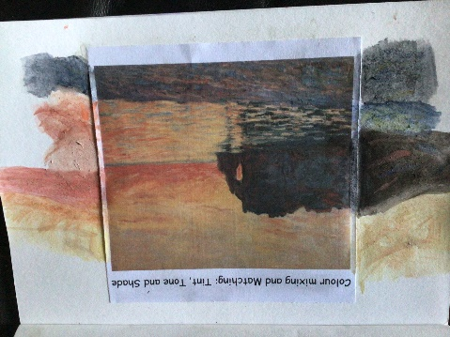  Use 2Paint painting program to create one of these images digitally  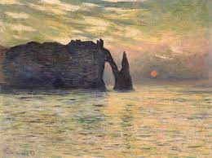.by Monet 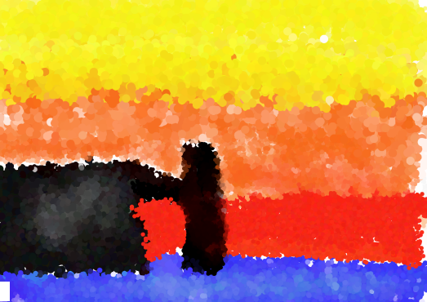by Y4  Why this? Why now?  Monet - the master of colour and he painted the same location at different times of the day and different times of the year. This work allows the children to focus on and discuss mood and how colour is used to create mood. Monet also spent a great deal of time painting coasts and rivers which links into the Y4 Geography topic. | Pollock,  Monet,  Chagall,  Ben Moseley,  Van Gogh,  Selection of others looked at, not in detail  BAME artists | To know how to apply colour by using different techniques eg: dabbing, stippling, pointillism, adding texture to paint (scratching), washes, splashing and using different tools.  To know how to describe an exact colour eg: tint – adding white to a colour, tone – how light or dark a colour is and shade – adding black to a colour.  To know how colour can be used to reflect mood.  To know that the colour wheel is a circular chart that shows primary, secondary and tertiary colours.
Printing  found materials, fruit/veg,  wood blocks, press print,  lino,  string | Use sketchbook for recording  textures/patterns  -Interpret environmental and manmade patterns  -Modify and adapt print | Make own prints in the style of John Muafengejo. The children will study the work of the celebrated Namibian printmaker John Muafengejo. The children will relate to his work as it features the animals of the African grassland. They will experiment with his mark making and will produce creative, individual pieces in that style. The teaching and learning will focus on the animal related pieces rather than his other work. The children will study why Muafengejo and his fellow artists used lino as it was a readily available material in the townships. The children themselves will develop their skills of press-print using foam or polystyrene rather than lino. Use of lino is developed in Year 6.  https://www.inyourpocket.com/johannesburg/the-art-of-trailblazing-printmaker-john-muafangejo_78345f  https://www.aspireart.net/auction/lot/115-john-muafangejo-namibia-1943-1987/?lot=7492&sd=1  https://www.aspireart.net/auction/lot/31-john-muafangejo-namibia-1943-1987/?lot=10076&sd=1  https://www.mutualart.com/Artwork/Giraffe-in-1979/CFF98FAA64E92E09  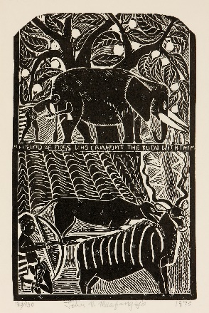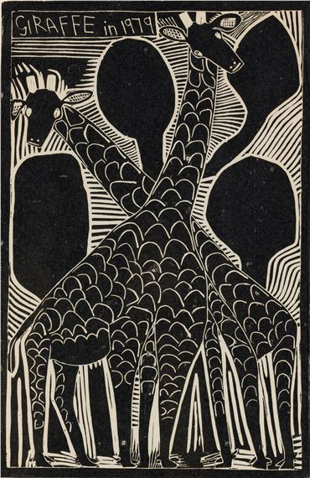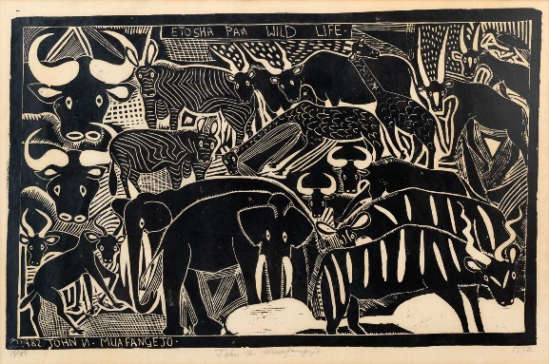  Study different animal prints and discuss why they have them  Use sketchbook for recording textures/patterns  Press print outline of an tiger, leopard or giraffe  -Interpret environmental and manmade patterns  Why this? Why now? Science is the grasslands because of studying food chains and also study a story based in South Africa where the animals are mentioned in the story. | Picasso,  Dan Mather, Andy Warhol  BAME artists  John Muafengejo | Know how to layer colour through print.  Know the effect layering colour can have on my artwork.  Know how to make informed choices on colour to create a desired effect.
Pattern  paint,  pencil,  textiles,  clay,  printing | -Explore environmental and manmade patterns  -Tessellation | -Explore environmental and manmade patterns  Pattern on Greek vases  Patterns of the Savannah animals Study animal prints as part of their preparation for creating a press print tile  Why this? Why now?  Pattern links to other areas of art and is focused on in the preparation for the children’s work. | Joan Miro, Bridget Riley, Escher,  Paul Klee,  BAME artists | Know how to explore environmental and man-made patterns  Know how to create tessellations and the effect that is will have

