Year 1 Art and Design Curriculum

 | Year 1 | Curriculum | Artists - artist studied | End points
Art appreciation | To recognise the work of particular artists and make links to their own work | - Sketch books are introduced in Year 1 even though this is not a requirement of the NC  - See school document ‘HCPS Art and Design – Guide to using sketchbooks  - Artists, craft makers and designers are studied throughout the Year 1 art curriculum | To be decided | To know that artists have their own style and that they can be inspired by it.  To know how to describe some simple characteristics of different kinds of art.  To know how to make a comment about a piece of art.  To know that a sketchbook is where ideas can be collected and skills can be practised.
Drawing  pencil,  charcoal,  inks,  chalk,  pastels,  ICT software | -Extend the variety of drawings tools  -Explore different textures  -Observe and draw landscapes  -Observe patterns  -Observe anatomy (faces, limbs) | - Autumn 1 Draw each other in different positions/poses.  - drawing tools – crayon, chalk, pencil, felt tips, poster paint.  - Draw light and dark lines (tone)  Why this? Why now?  Links to science and senses - progression from reception where they will have drawn self-portraits and portraits. Here they develop their drawing further by drawing each other in different positions and poses.  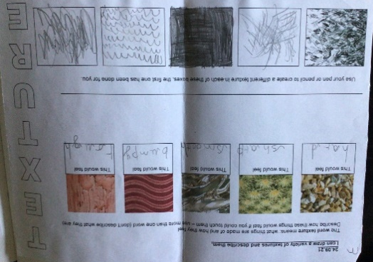  - Looking for shapes in the environment (patterns) – Linked to history/geography Autumn 1/2  - Series of lessons exploring textures using pencil Autumn 1  - Autumn 2 Draw landscapes around Holmes Chapel  - Create rubbings (texture)  - Observe and draw shapes.  - Observe and draw patterns using pencils, crayons, felt tip pens  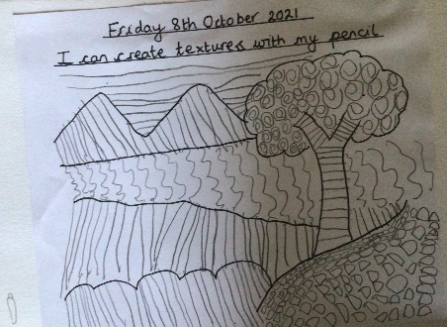  Why this? Why now?  Autumn 1 learning about the British Isles - Link to key iconic locations such as the Giant’s Causeway etc. and drawing landscapes  Autumn 2 Draw landscapes around Holmes Chapel such as the Twemlow Viaduct and Jodrell Bank as learning about Holmes Chapel in Geography. Apply knowledge gained about textures and shapes in the environment. | Leonardo  Da Vinci,  Vincent  Van Gogh,  Poonac  BAME artists | Know how to draw with a wide variety of drawing tools and how to use an effective grip.  Know how to use line, shape and being to use tone in their drawings.
Colour  painting,  ink,  dye,  textiles,  pencils,  crayons,  pastels | -Name all the colours  -Mixing of colours  -Find collections of colour  -Applying colour with a range of tools | - Series of lessons focused on naming and mixing of colours Autumn 2/Spring 1  - Using poster paints  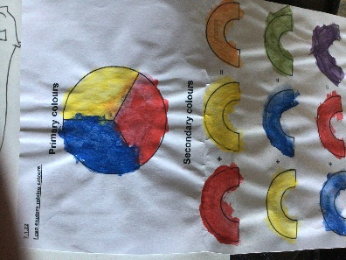  - Name colours  - Experiment with colours  - Mix primary colours to make secondary colours  - Apply colour with different tools – brushes, rollers, fingers etc  - Create repeating patterns  Spring 1 and Printing Half –timbered buildings on fire! Creating a picture of a half-timbered house on fire. Sponge print the flames with a focus in colour mixing (oranges, reds, yellows). Onto grey board stick art straws to form the outline of the half-timbered building, Roller printing blacks and browns to create the wood. Why this? Why now? Studying in history the Great Fire of London and it allows the children to apply their knowledge of colour and colour mixing to a piece of art. Look at wood cut printing as part of history of art.  Seasons calendar Autumn 2 – silhouette of four trees. Children dab on colour using fingers. Discuss how different colour sets are associated with different seasons.  Mix different season colours in sketch books and use different tools eg fingers, paint brush, cotton bud. Children to discuss the effects of the different tools and which they prefer and why. Also note the different effects that happen  Why this? Why now? Applying colour using a range of tools, applying knowledge and experiment with mixing colour by laying colours on each other.  MOMA New York season interactive video  Autumn 2 – Firework pictures done in pastels  Why this? Why now? Links with Bonfire Night PSHE, poetry and music. Develop skills of using different media to create different colour effects. | Pollock,  Monet,  Chagall,  Ben Moseley,  Van Gogh,  Picasso  Cezanne  BAME artists | To know how to mix two primary colours to make a secondary colour (orange, green and purple).  To know how to use line, shape and colour in their work  To know how to use a variety of painting tools (eg: fingers, brushes, pencils, flat tools such as clay tools, lollipop sticks) and the effects they create.  To know how to use an effective grip to control a wide range of painting tools (including different types and sizes of brushes).
Texture  textiles,  clay,  sand,  plaster,  stone | -Weaving  -Collage  -Sort according to specific qualities  -How textiles create things | - Summer 1 and 2 Create a landscape out of two large sticks/batons. Weave through different materials. Children create simple paper woven animals/creatures  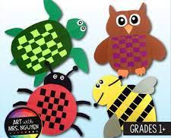  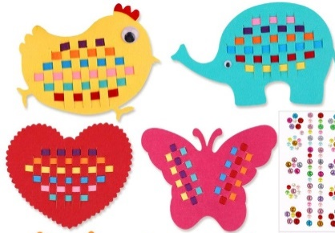  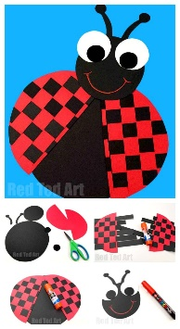  - Create fabrics by weaving – use man-made and natural materials ie grass through twigs, plastic through fence, wool around lolly sticks etc  Why this? Why now? Links with science work on animals including humans. It also links back and builds upon the skills developed in EYFS of collage and texture of an underwater scene.  - Autumn 1 Welsh Dragon – tones and texture.  - Introduce adhesives – pritt and PVA  - Fold, crumple, tear, overlap and sort different materials  Why this? Why now? Linked to English and stories on Welsh Dragons. Materials linked with science Autumn 2 | Linda Caverley, Molly  Williams, William Morris,  Gustav Klimt | - Know how to use simple textile techniques eg- sewing , weaving , dyeing- dipping)  Know how to identify different types and textures of materials for collage.  Know how to tear, stick and cut paper of different thicknesses.  Know how to place and modify elements of collage.  Know how to use appropriate language to describe colours, equipment and processes.
Form  3D work,  clay,  dough,  boxes,  wire,  paper sculpture, mod roc | -Construct  -Use materials to make known objects for a purpose  -Carve  -Pinch and roll coils and slabs using a modelling media  -Make simple joins | 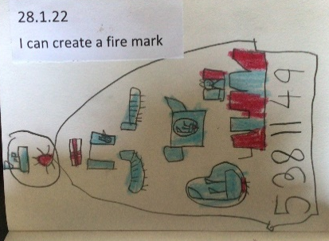  - Fire marks made with clay Spring 1 Children design their own clay fire mark. The children use different tools to make mark by scrape it out. Children to pinch a border and add a coil of clay using score and slip.  - Roll, carve, make marks on and knead malleable materials – dough, plasticine and use them to make objects for a purpose.  - Use patterns.  Why this? Why now? Links to the topic ‘The Great Fire of London’.  Before there was a national Fire Service and people would pay into private companies. If you did, a fire mark would then be put onto your house as a clay marker. If your house was on fire the private company would know whether to save your house or not! | Henry Moore, Barbara  Hepworth, Andy  Goldsworthy,  BAME artists | Know how to manipulate and explore materials - clay  Know how to use tools safely and effectively on clay  Know how to use simple joining and fastening techniques on clay
Printing  found materials, fruit/veg,  wood blocks, press print,  lino,  string | -Create patterns  -Develop impressed images  -Relief printing | Spring 1 and Printing Half –timbered buildings on fire! Creating a picture of a half-timbered house on fire. Sponge print the flames with a focus in colour mixing (oranges, reds, yellows). Onto grey board, stick art straws to form the outline of the half-timbered building, Roller printing blacks and browns to create the wood.  Create repeating patterns  Observe and recognise patterns in the environment  Relief prints using art straws and grey board  Create patterns  Why this? Why now? Studying in history the Great Fire of London and it allows the children to apply their knowledge of colour and colour mixing to a piece of art. Look at wood cut printing as part of history of art. | Picasso,  Dan Mather, Andy Warhol  BAME artists | Know what a repeated pattern is.  Know that a repeated pattern can be created through print.  Know how to create a printed image by press printing and relief printing.  Know how to interpret ideas into print.
Pattern  paint,  pencil,  textiles,  clay,  printing | -Awareness and  discussion of patterns  -Repeating patterns  -Symmetry | Pattern is a theme that goes through the Year 1 art curriculum – look at pattern in the environment as part of landscapes, look at patterns as part of fireworks, pattern in clay firemarks, symmetry in patterns as part of half-timbered buildings, look at patterns made when weaving. Through this the children will use paint, pencil, textiles, clay and printing | Joan Miro, Bridget Riley, Escher,  Paul Klee,  BAME artists | Know that there is pattern and discuss patterns  Know how to create repeated patterns  Know that there is and recognise symmetry in art

