Year 3 Art and Design Curriculum

 | Year 3 | Curriculum | Artists - artist studied | End of year expectations
Art Appreciation | To know about great artists, architects and designers and understand how their work was shaped by the historical and cultural context in which it was created. | - Sketch books are introduced in Year 1 even though this is not a requirement of the NC  - See school document ‘HCPS Art and Design – Guide to using sketchbooks  - Great artists, architects and designers are studied throughout the Year 3 art curriculum | Cave art – Lascaux  Egyptian Art  Henri Rousseau | Know how to create a piece of work, taking inspiration from famous artists, architects and designers.  Know some of the starting points, processes and techniques used by famous artists, architects and designers in history.  Know how to use their sketchbook to collect and record visual information from different sources.  Know how to express an opinion on the work of famous, notable artists, architects and designers.
Drawing  pencil,  charcoal,  inks,  chalk,  pastels,  ICT software | -Experiment with the potential of various pencils  -Close observation  -Draw both the positive and negative shapes  -Initial sketches as a preparation for painting  accurate drawings of people – particularly faces | Autumn 2- Cave Art (cross curricular-History)  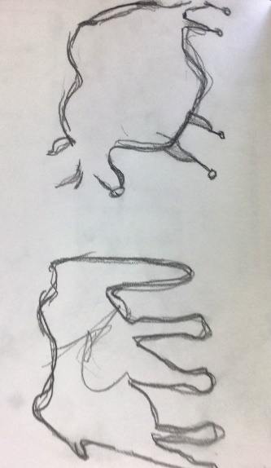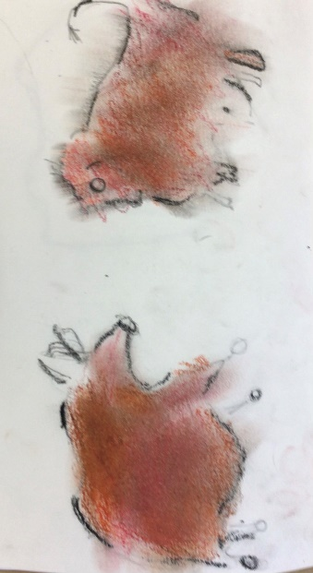  Make marks and create texture with different drawing implements – pencil, oil pastel, charcoal – develop by colouring in the negative space  Why this? Why now?  Art linked to the history topic – The Stone Age to Iron Age. Look at the cave drawings, why they were done, the materials they had eg berries, burnt sticks, How stories were told through them – study the history of the art. Look at the famous French Lascaux cave art.  Spring self-portraits  Step 1 to draw in the rest of their face from a half photo (face on)  Step 2 to draw their self-portrait full face on  Step 3 to draw their side-on portrait from a photograph – link to Egyptian art where was sideways on. Learn about why the Egyptians drew like that when today we do full-face views. Consider – Egyptianising their side on drawings  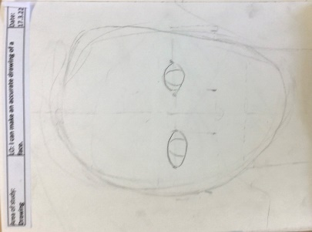  Use different grades of pencil to apply tone to drawings  Why this? Why now?  Linked to the mask of Cleopatra – study the mask. What was it made for? What was it made of? Children are building on drawing skills developed in year 2 and are adding a 3rd dimension to their drawings.  Experiment with different grades of pencil, cross hatching, blending | Leonardo  Da Vinci,  Vincent  Van Gogh,  Poonac | Know why they are using different grades of pencil and other implements (e.g. pastels, charcoal, pencil etc) in their drawing.  Can draw for a sustained period of time.  Know how to use different media to achieve variations in line, texture, tone, colour, shape and pattern.  Know how to show in their drawings that objects have a third dimension.
Colour  painting,  ink,  dye,  textiles,  pencils,  crayons,  pastels | -Colour mixing  -Make colour wheels  -Introduce different types of brushes  -Techniques- apply colour using dotting, scratching, splashing | Summer 1- Mix colours and know which are primary, secondary and tertiary colours. Use specific colour language. Use the colour mixing skills they acquire to produce a background for their scratched work.  Make colour wheels. Build on from Y1 and Y2 work  Patterns in the environment (cross curricular- Geography) inspired by Henri Rousseau jungle pictures. Look at how he uses colour in his work and identify which colours he uses predominantly, and then zoom in and choose a focal point to look at pattern. Recreate focal point using two different techniques – dotting and scratching.  https://www.twinkl.co.uk/resource/t2-a-062-henri-rousseau-photopack-and-prompt-questions  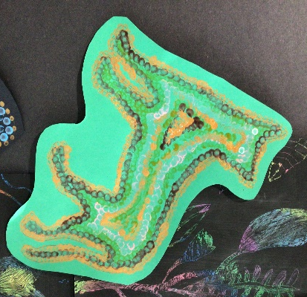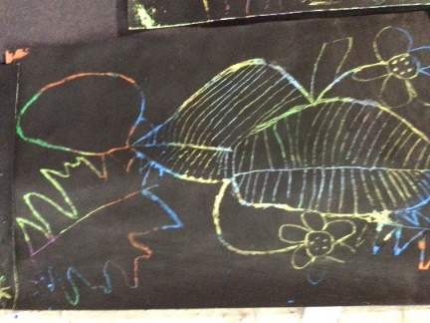  Experiment with effects and textures – dotting, scratching, splashing  Why this? Why now? Links to Year 3 science: animals including humans, plants and geography topic where they study different climate zones, biomes and vegetation belts and the significance of the lines of latitude to these. They start their work on contrasting climates with the study of rainforests, focusing primarily on the Amazon Rainforest and those found further north in The Caribbean. | Pollock,  Monet,  Chagall,  Ben Moseley,  Van Gogh, | To know how to apply colour by using different techniques eg: dabbing, stippling, pointillism, adding texture to paint (scratching), washes, splashing and using different tools.  To know how to describe an exact colour eg: tint – adding white to a colour, tone – how light or dark a colour is and shade – adding black to a colour.  To know how colour can be used to reflect mood.  To know that the colour wheel is a circular chart that shows primary, secondary and tertiary colours.
Texture  textiles,  clay,  sand,  plaster,  stone | -Use smaller eyed needles and finer threads  -Weaving  -Tie dying, batik | Clay Design tiles linked to Henri Rousseau work – focusing on leaves and flowers for ease.  Children to decide on design (in 2D form) and create using salt dough (in 3D form) to practise rolling out and cutting out a tile, scratching into a surface, rolling out very thin worm-like strands, rolling small bobbles, attaching relief elements to the tile, adding texture and depth with tools – can be dried if wanted.  Repeat with clay. Allow clay to air dry and then paint if wanted.  https://thatartteacher.com/2019/11/09/how-to-make-textured-tiles-slab-clay-lesson-plan-art-teacher-diy/  .  Why this? Why now? To follow on from Year 1 Fire marks made with clay Spring 1 where children design their own clay fire mark and scratched design.  Year 5 to make clay pinch pots using relief as a progression from Year 3  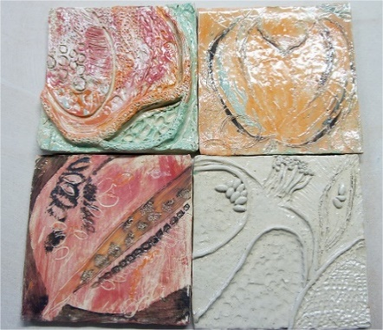 | Linda Caverley, Molly  Williams, William Morris,  Gustav Klimt | Know how to create a plan for developing a 3D form  Know how to transfer skills from 2D to a 3D form  Know how to select appropriate tools and use effectively  Know how to combine and manipulate materials effectively
Form  3D work,  clay,  dough,  boxes,  wire,  paper sculpture, mod roc | -Shape, form, model and construct  (malleable and rigid materials)  -Plan and develop  understanding of different adhesives and methods of construction  -Aesthetics | Summer 2-  Design tiles linked to Henri Rousseau work – focusing on leaves and flowers for ease.  Children to decide on design and create using salt dough to practise rolling out and cutting out a tile, scratching into a surface, rolling out very thin worm-like strands, rolling small bobbles, attaching relief elements to the tile, adding texture and depth with tools – can be dried if wanted.  Repeat with clay. Allow clay to air dry and then paint if wanted.  Why this? Why now? To follow on from Year 1 Fire marks made with clay Spring 1 where children design their own clay fire mark and scratched design.  Year 5 to make clay pinch pots using relief as a progression from Year 3 | Henry Moore, Barbara  Hepworth, Andy  Goldsworthy,  BAME artists | Know how to create a plan for developing a 3D form  Know how to transfer skills from 2D to a 3D form  Know how to select appropriate tools and use effectively  Know how to combine and manipulate materials effectively
Pattern  paint,  pencil,  textiles,  clay,  printing | -Pattern in the environment  -Design  -Using ICT  -Make patterns on a range of surfaces  -Symmetry | Summer 1- Patterns in the environment (cross curricular- Geography) inspired by Henri Rousseau  Why this? Why now? Links to Year 3 science: animals including humans, plants and geography topic where they study different climate zones, biomes and vegetation belts and the significance of the lines of latitude to these. They start their work on contrasting climates with the study of rainforests, focusing primarily on the Amazon Rainforest and those found further north in The Caribbean. | Joan Miro, Bridget Riley, Escher,  Paul Klee, | To know about patterns in the environment  To know how to make patterns on a range of surfaces

