Reading Prompt Question Starters

Understand, describe, select or retrieve information

List…

Select a word that shows who… what… what…

Give one reason…

Match…

Which word means…

Find…

Interpret information from texts

How did … feel?

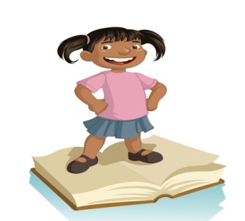Why did… think?

Why did… feel?

Why is … important?

How do we know…?

What does this tell us about how … is feeling/thinking?

How?

Why?

Explain why…

Explain how…

Identify the structure and organisation of a text (grammar)

What is the purpose of…?

What are the … for?

How does the last section prepare the reader for the ending?

Why is the … word in bold print? Italics?

Match the sub heading to the paragraph.

How does the paragraph create an atmosphere of?

Explain why … has been placed at the beginning?

Comment on the writers use of language

Find two words (or phrases) that make the passage seem?

What is the effect of…?

Why has the writer used the word…?

Explain why the words … make it seem…?

j0229905