Maths – addition and subtraction (2)
Column addition with regrouping

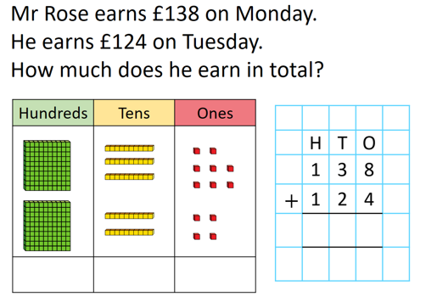
We always begin with the least significant digit – the ones.
8 + 4 = 12
As we can’t have a number greater than 9 in any column, the ones will need to be regrouped into tens and ones. The ten then needs to be put into the tens column
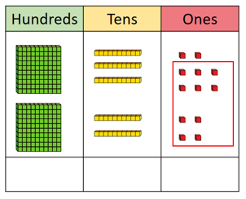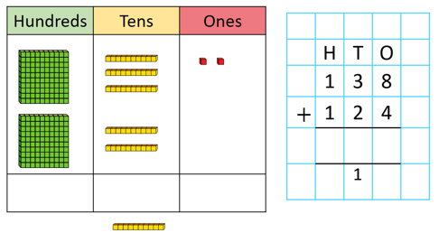
Then we can continue with adding the amounts in each column.
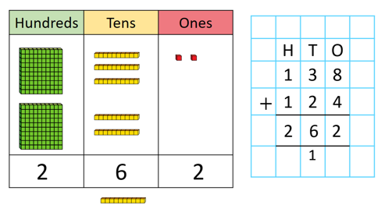
The same process is used to regroup tens into hundreds or hundreds into thousands.
The 138 and 124 we call the addends.
262 we call the sum.

